InIt POS Terminal user’s Manual

1. **Introduction 3**
2. **System Operations 4**

2.1 Initial Sync 4

2.2 Initial Terminal Setup 5

2.3 Day start 9

2.4 Open Till 11

2.5 Attendance Module 13

2.6 Summary Module 14

2.7 Order Entry Module 14

2.7.1 Top Panel 15

2.7.1.1 Service Button 15

2.7.1.1.1 Take Away Service 16

2.7.1.1.2 Home Delivery Service 16

2.7.1.1.3 Table Service 16

2.7.1.2 New Button 17

2.7.1.3 Park Button 18

2.7.1.4 Open Button 18

2.7.1.5 Info Button 18

2.7.1.6 Customer Button 18

2.7.1.7 Message Button 18

2.7.1.8 Menu Button 18

2.7.1.9 More Button 18

2.7.1.10 Lock Button 18

2.7.1.11 Exit Button 18

2.7.2 Message Panel 19

2.7.3 Order List Panel 19

2.7.4 Item List Panel 19

2.7.5 Item Class List Panel 19

2.7.6 Bottom Panel 19

2.8 Shift Reports 20

2.9 Order List 20

2.10 Daily Expenses 20

2.11 Reports 20

2.12 Sync Now Module 20

2.13 Terminal Module 20

2.14 Mails Module 20

2.15 Support Module 20

2.16 Open Sessions Module 20

2.17 About 20

2.18 Exit 20

# **Introduction**

Every restaurant needs a best-in-class, efficient, easy to use and enterprise level sales management system. Here we have a system which meets all these requirements.

# **System Operations**

## **2.1 Initial Sync**

Double click on the POS system icon on the Desktop, a new window will open on the desktop as shown below. If it is the first time you use the system, we have to initially sync the system with the server database. 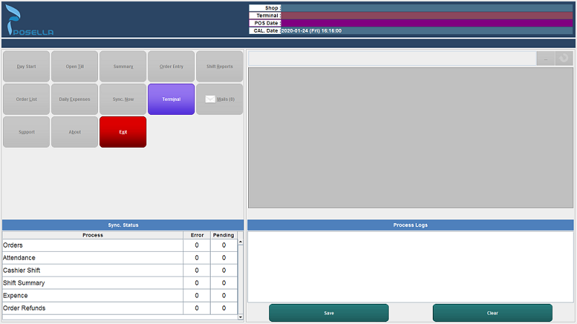

Fig: Initially opened window

Select the Terminal button from the window, popup a new window as shown below to enter the shop code given by the user while register the shop details in the server and then click the OK button.

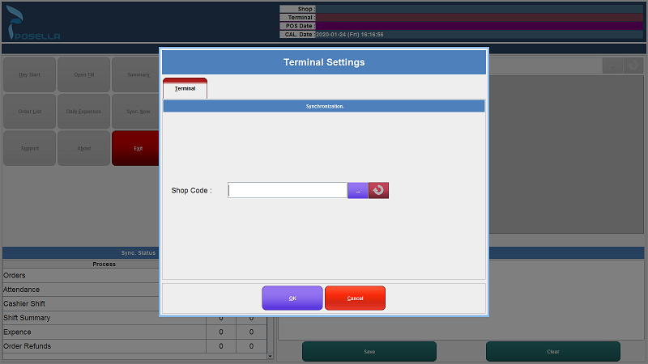

Fig: Terminal Setting

If there is no error occur for data synchronization, popup an alert box as shown below.

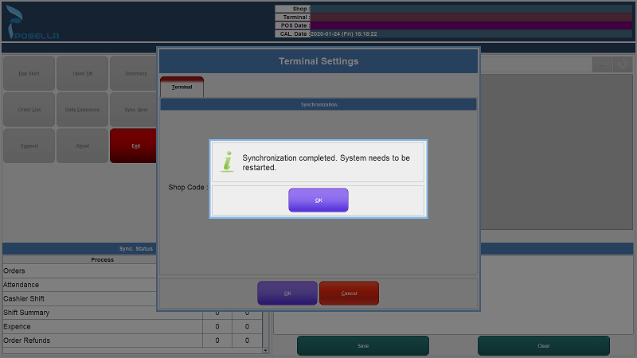

## 

## 

## Fig: Alert message after synchronization completed

Click the OK button, then the system will restart.

## **2.2 Terminal Setup**

###### **2.2.1 Terminal**

Double click on the POS system icon on the Desktop, a new window will open on the desktop as shown below.



Fig: Terminal Setting

Select the Terminal button from the window, popup a new window as shown below to set the terminal initial settings. The external devices are connected to the application by installing the devices initially in the gadget and adding the devices to the application in the terminal settings.

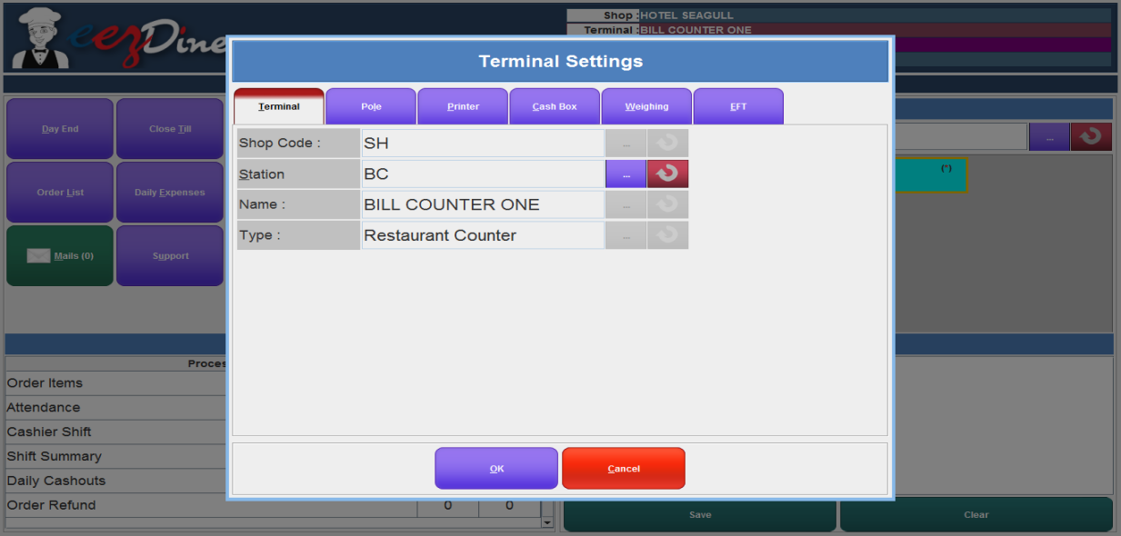

Fig: Terminal side settings for shop

Select the Terminal option, then type the Shop Code, then station the station from the list. For selecting the station click the button on the right side of the station field. When clicking the button, popup a new window as shown below.

## 

Fig: Station list

Select a station from the list, then auto populate the remaining fields.

**2.2.2 Printer Settings**

Select the Printer option from the terminal settings window, open a new window to set the printer settings as shown below.

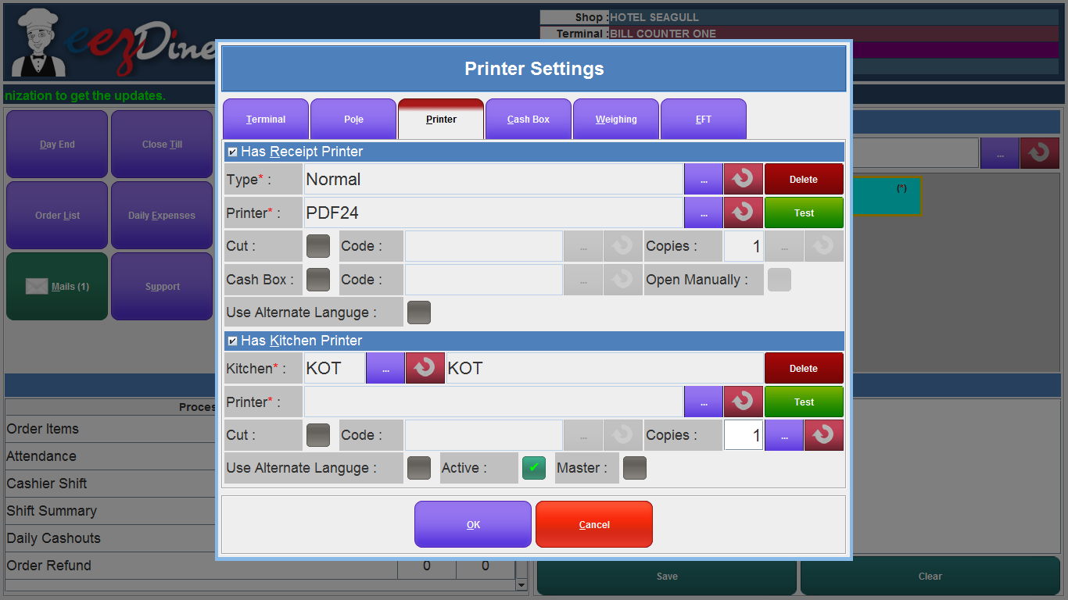

Fig: Printer Settings

Select the checkbox named Has Receipt Printer, then click the button on the right corner, then popup a new window with the list of printer type as shown below.

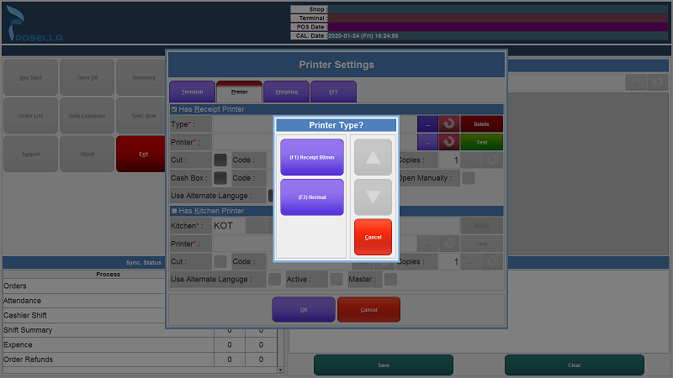

Fig: list of printer types added

Select the printer type from the list then auto populate the name in the field. Then click the button on the right side of the printer field. Then popup a new window with the list of printers can be accessed by the system as shown below.

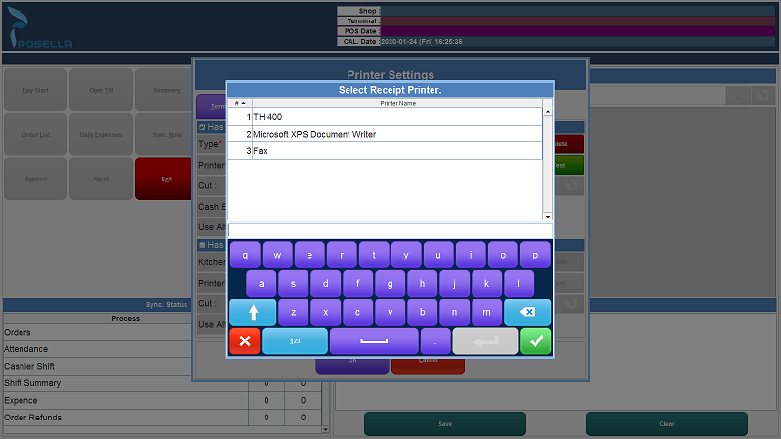

Fig: list of Receipt printer added

Select the printer then click the tick mark shown in the window. Then you can check the printer to give the test print to the printer by clicking the Test button. Then select the checkbox named Has Kitchen Printer, then click the button shown on the right side of the field then select the kitchen and set the printer to the kitchen same as above.

###### **2.2.3 Pole Display Settings**

The Pole Display machine is used for show item and price information to the customer. If you are using a Pole display, connect the pole display to the POS system. Pole display settings are seen in the terminal side settings. Select the Pole button to setup the Display Pole Machine. When we click the Pole button, the window changed for the Pole display settings. Click the tick mark shown in the window Has Pole. then the fields are enabled to make changes. Setup all the fields as per the need. We can set the number of rows and columns, move command, clear command, clear line command, port number, startup message, new bill message, closed message, baud rate, data bits, parity and stop bits. Check if the given datas is correct or not. If there is any correction in any field click the refresh button seen in every field and re enter the valid data. The pole display settings window as shown below.

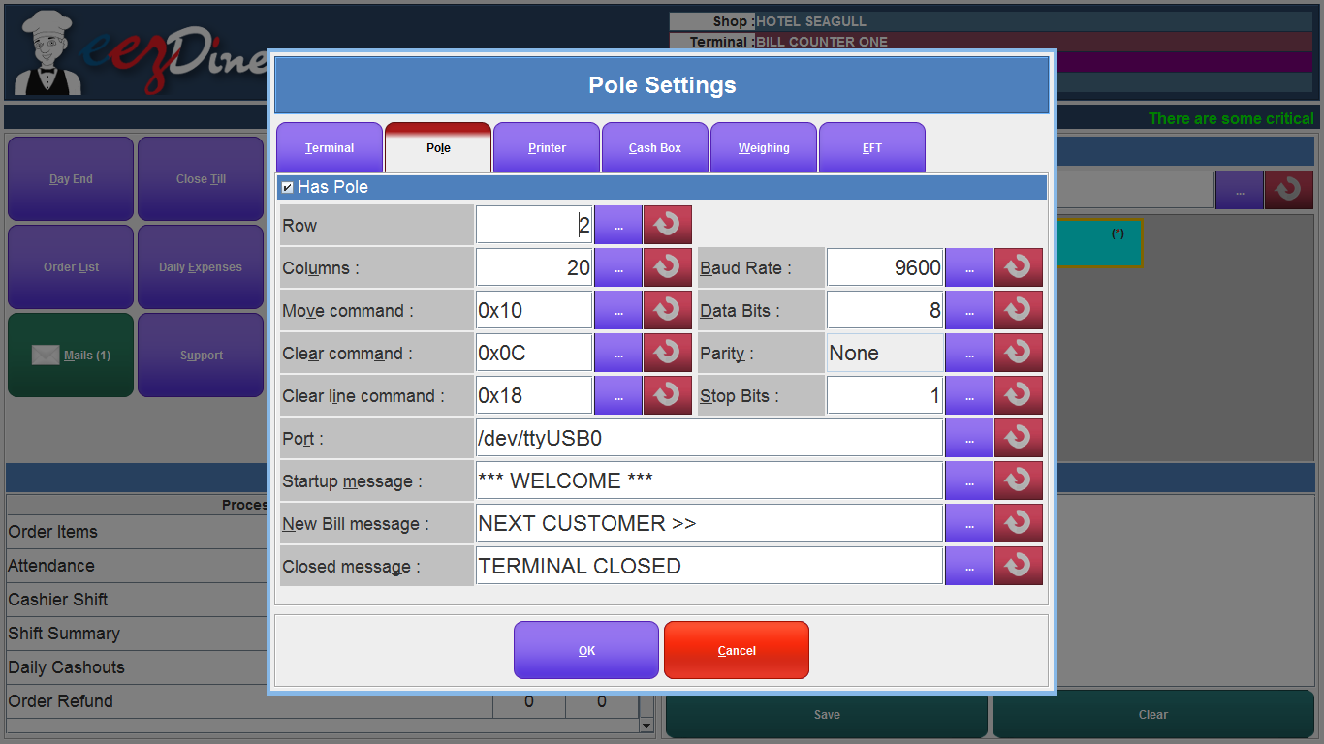

Fig: Pole display machine setup window

###### **2.2.4 Cash Box Settings**

Cash Box is the essential part of the POS system. Cash boxes are used for storing cash during and between POS transactions. If you are using a cash box in your POS system, connect the cash box to the POS system initially. Select the Cash Box option from the terminal settings window and put a tick mark to the field that has a cash box to enable the settings and enter the cash box control code, port type and port. If you want to open the cash box manually, put a tick mark to the field allow open manually. Then if you want to test the working of the cash box click the test button. The cash box setting window as shown below.

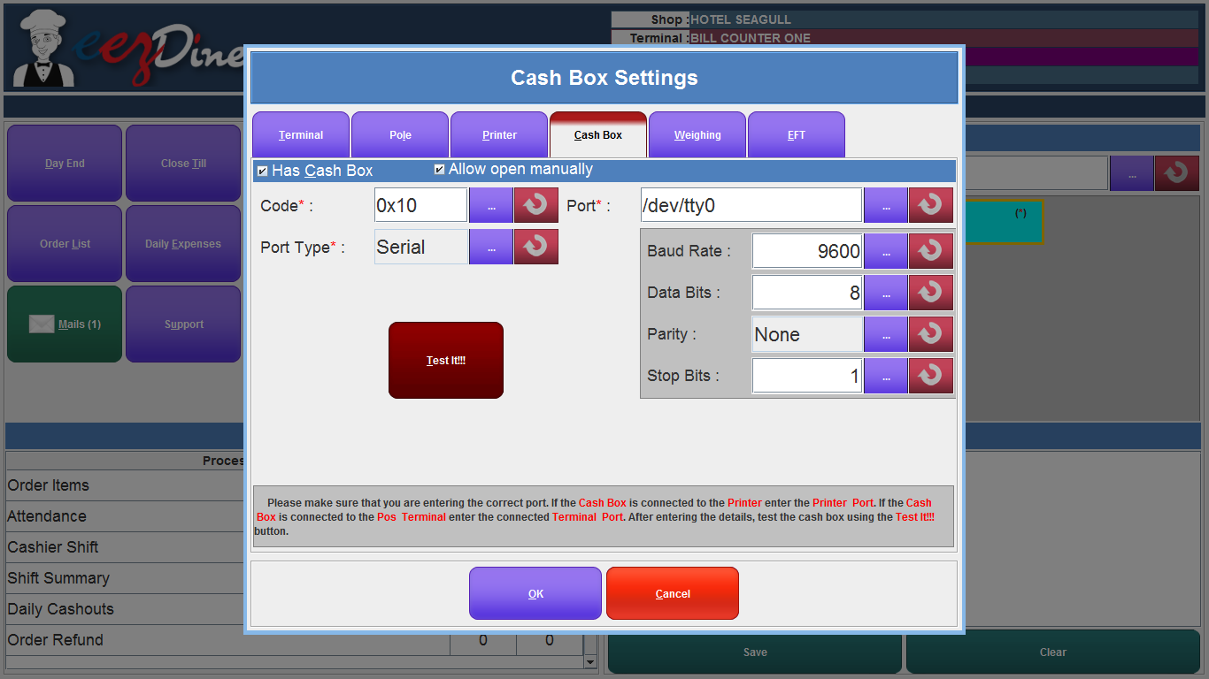

Fig: Cash Box setup window

**2.2.5 Weighing Machine**

Weighing machines are used for weighing the products and populating the weight in the POS system directly. If you are used weighing machines, connect the machine to the POS system. Select the weighing option from the terminal window for the setup. Then put a tick mark in the Has weighing field and enter the valid values in the fields. If you want to check the weighing machine is properly working, click the test button to test the machine. The weighing machine setting window as shown below.

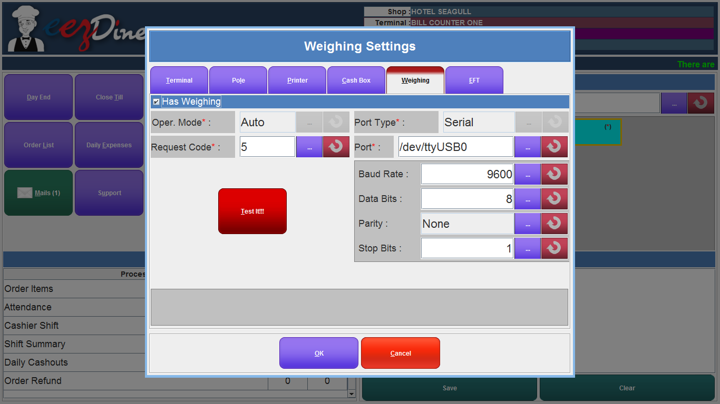

Fig: weighing machine setup window

###### **2.2.6 EFT Setting**

If your shop uses any online applications for sale, EFT settings are used for connecting the online application to the POS system. Select the EFT from the terminal settings and put tick mark to the field Has EFT and enter the host IP address, host Port number and setting the time out in the given fields. If you want to open a cash box while using this application, put a tick mark on the field. The EFT setting window as shown below.

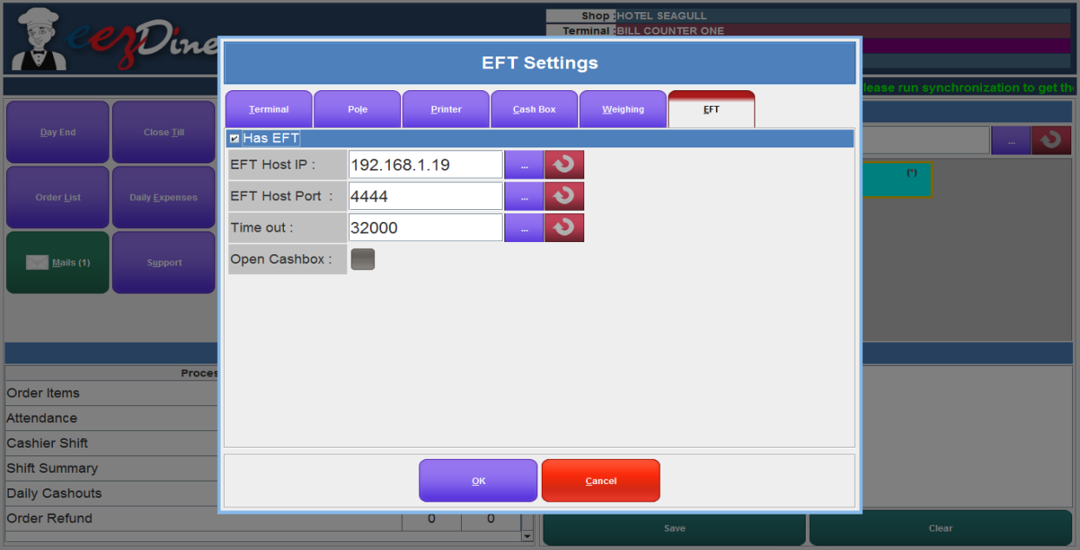

Fig: EFT setup window

Then click the OK button from the window, it will popup a message as shown below.

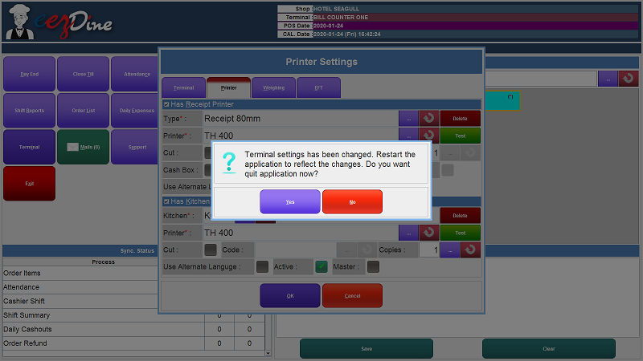

Fig: Alert message after terminal side settings are completed

Click the Yes button. Now the terminal settings have changed, then the application will restart .

## **2.3 Day start**

The application will restart after the terminal settings are done. A new window will open as shown below.

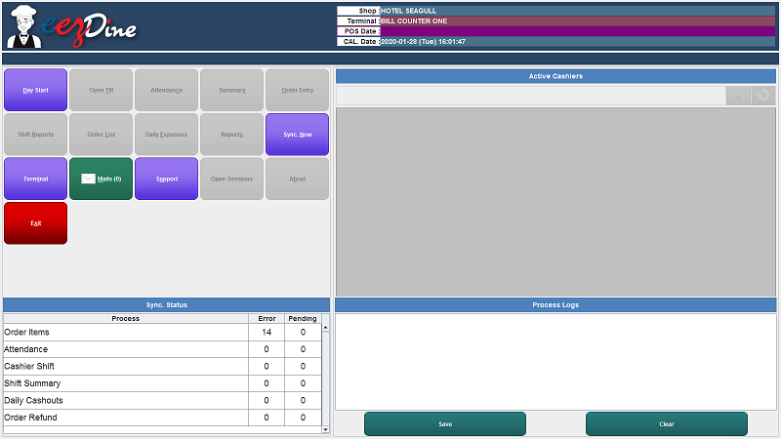

Fig: day start

Select the Day Start button to start the day by the user. Then popup a dialog box to set the current date as shown below.

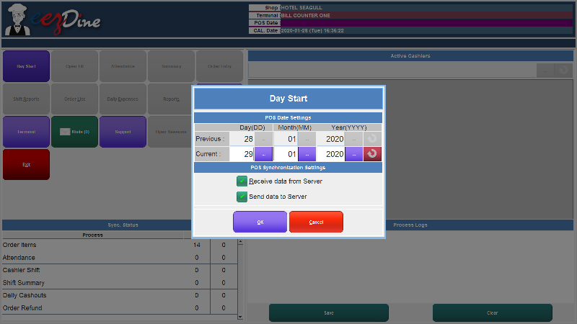

Fig:POS date settings

Select the current date and click the OK button. Then popup a window for user authentication as shown below.

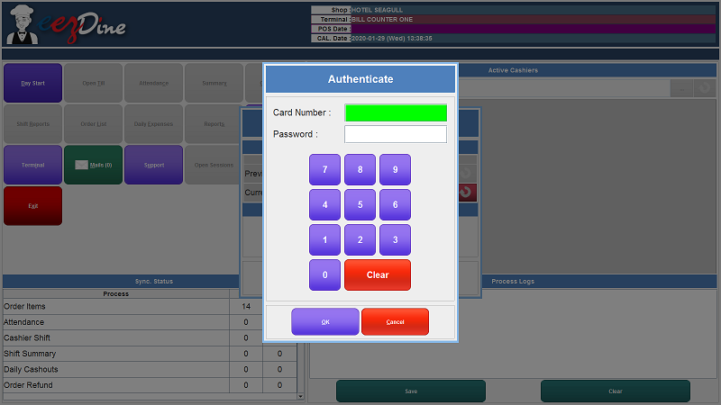

Fig: user authentication window

Enter the valid card number and the password of the user, and then click the Ok button. If you are entering the wrong card number and password, then the application will authenticate the user and will show a message as shown below.

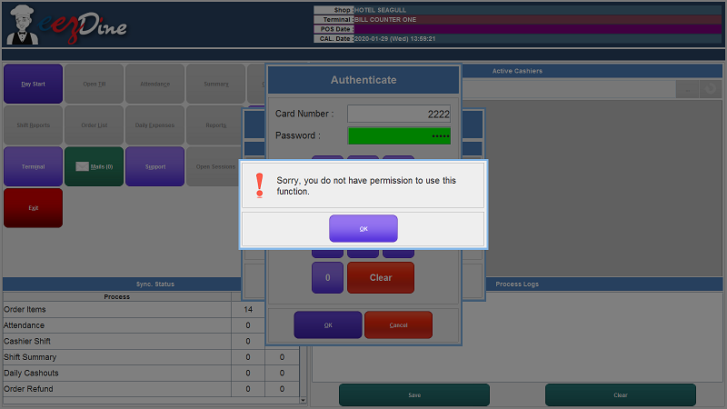

Fig: Alert message for invalid user entry

Always try to enter the valid card number and password for authentication. Then the day start will processed

## **2.4 Open Till**

A new window will be shown as below after the day start process will be completed.

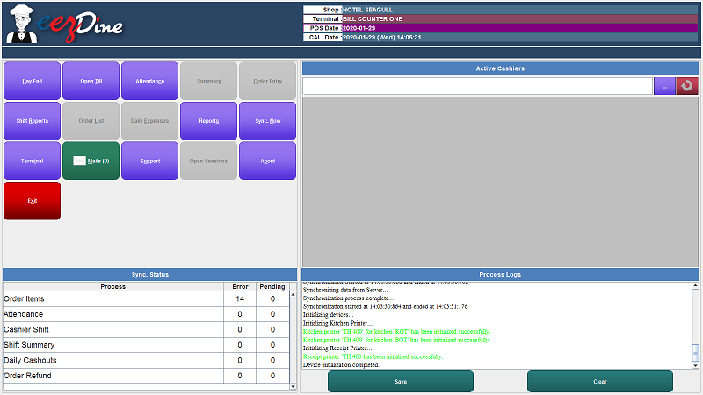

Fig: POS window

Then click the Open till Button to open the till. Then a user authentication window will open as shown below

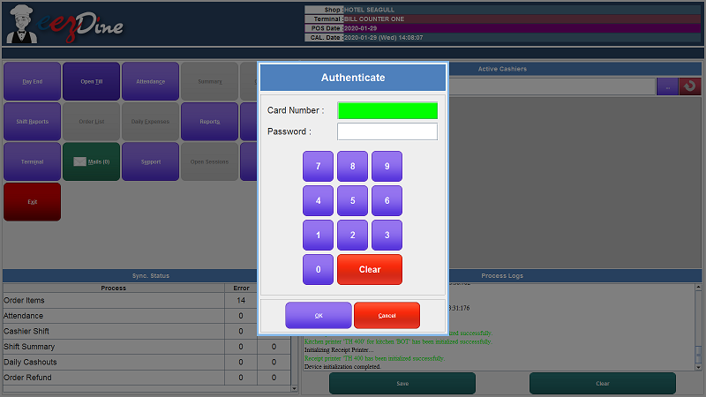

Fig: User authentication window

Enter the Card Number and Password again for user authentication, Then click the Ok button. Popup a new dialog box as shown below to enter the opening amount kept in the shop. The card number and the user details are auto populate the required fields.

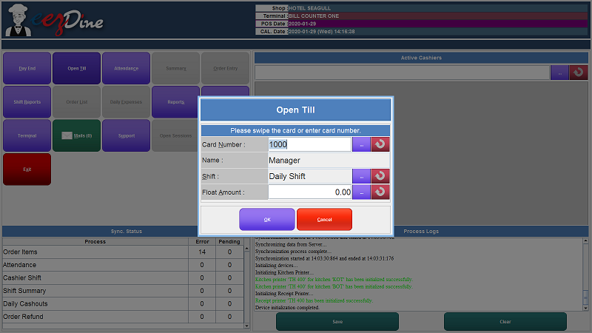

Fig: Open Till

And also we can select the shift we want to be active from the dialog box. Click the button on the right side of the shift field, then any shift from the list shown. then the float amount and click the Ok button. Then popup a dialog box to enter the user password again as shown below, then click the Accept button.

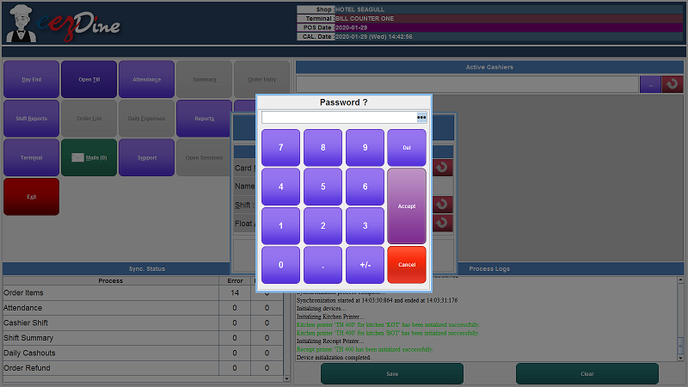

Fig: password validation

Then the authentication processes are almost complete in this session. When we click the Accept button, a new window will be shown as below.

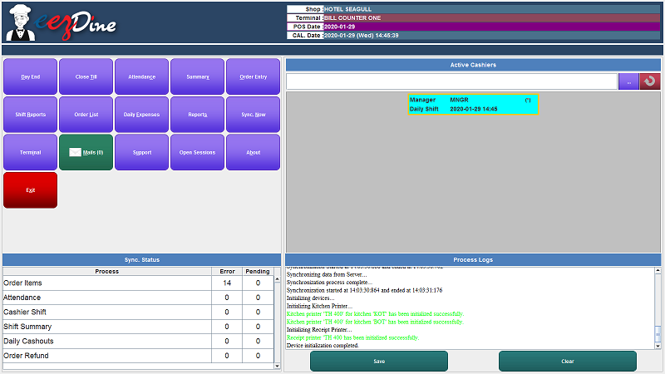

## 

## 

## 

## 

Fig: POS window after open till

This window will show different features of the application. An authenticated user can enter this window for different purposes.

## **2.5 Attendance Module**

Attendance Module used to enter the attendance of each of the employees in the shop. Every employee should enter the IN and OUT time in this application. When we click the attendance button, a dialog box will be shown as below. Enter the valid Card Number, then auto populate the name of the employee in the name field then click the IN button.

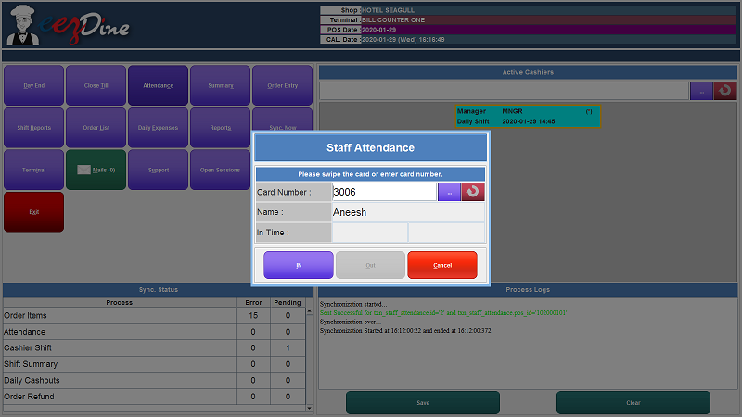

Fig: Staff Attendance

## **2.6 Summary Module**

The Summary Module is used to take the shift summary report. When we click the Summary Button, popup a dialog box to enter the valid card number and password then click the Ok button. Then the shift report will display on the screen as shown below. Click the print button to take print of the shift summary report whenever we need it. Otherwise click the Close button after checking the report details.

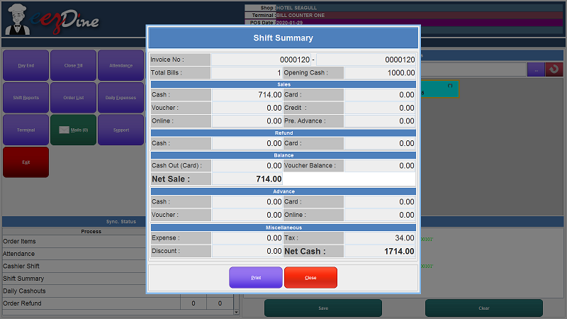

## 

## 

## 

## 

Fig: Shift Summary Report

## **2.7 Order Entry Module**

Order Entry Module used to enter the order details in the shop. Click the Order Entry Button, then popup a user authentication dialog box for validation. Enter valid Card number and password. After entering the valid card number and password click the Ok button. A new window will be opened as shown below. This screen will be divided by many panels such as order list panel, top panel, message panel, item class list panel, bottom panel and item list panel. Each panel has many buttons and each one has its own functionalities.

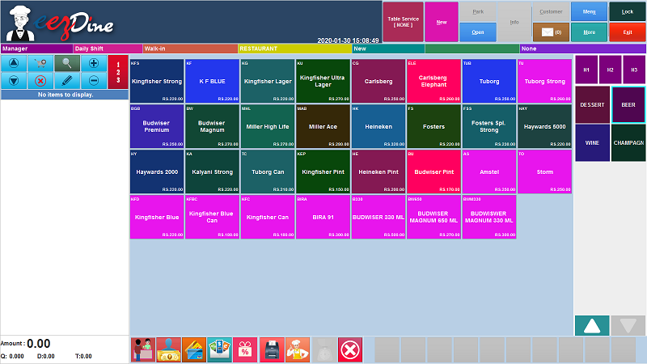

## 

## 

## 

## 

## 

Fig: Order Entry Window

#### **2.7.1 Top Panel**



Fig: Top Panel

This is the top of the screen shown above. The top panel contains 11 buttons, such as Service button, New button, Park button, Open button, Info button, Customer button, Message button, Menu button, More button, Lock button and Exit button. Each of it has its own functionalities.

##### **2.7.1.1 Service Button(Take Away)**

Fig: Service Button

Click this button to select the service we want. When we select this button popup a list of services provided by the shop as shown below. We can select the service we wanted from this list, otherwise click the Cancel button shown in the list to cancel it.

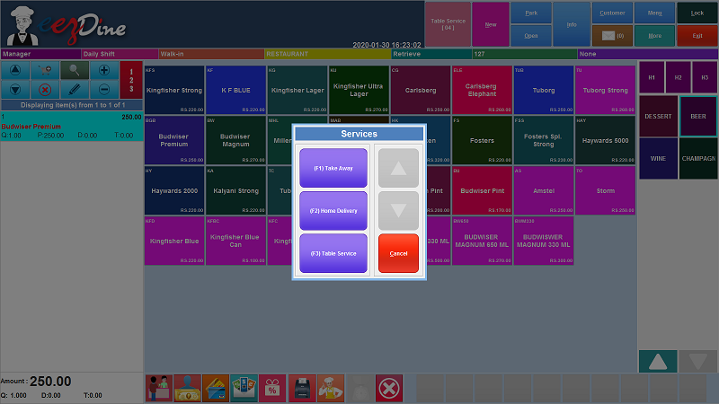

Fig: Services list

We have to see that there are five services with their codes listed in the dialog box shown above. Take Away service, Home Delivery Service and Table Service. The arrow buttons shown in the dialog box used to scroll the list, if we have more services. Then the Cancel button used to cancel the attempt and go back to the screen.

###### **2.7.1.1.1 Take Away Service**

Take Away service means that the food ordered by a customer is to be taken home or anywhere rather than eating in that place, that is packed to have it at home. An order placed in the take

away services first we select the service from the service button shown in the top panel. Then select the items as per the customer requirement then park the order to the kitchen.

###### **2.7.1.1.2 Home Delivery Service**

Then the Home Delivery service is the bringing of items to the customer’s home rather than the customer taking or collecting them from the shop. An order placed in the home delivery service first select the service from the service button shown in the top panel. If we select the home delivery service, popup a new window as shown below.

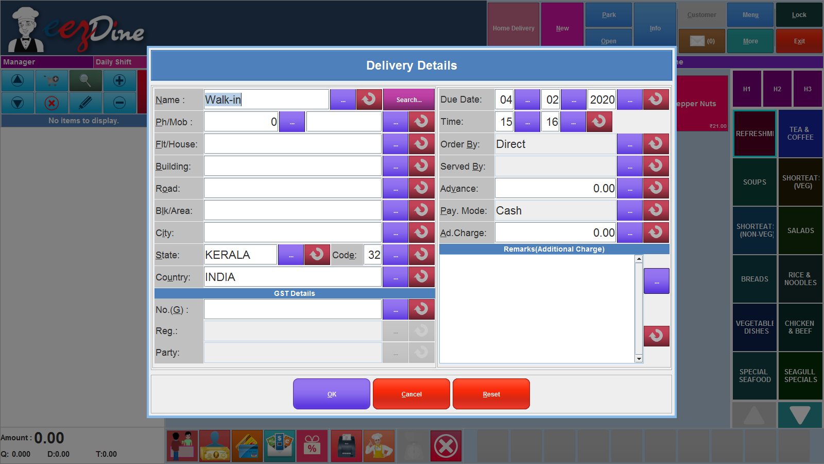

Fig: Delivery Details

This window used to enter the delivery details.

The fields are mandatory. Then first field Name is used to enter the name of the customer. Here we have a default customer walking, otherwise we can enter the customer details as per the field requirement and also we can select the registered customers from the list by clicking the search button on the right corner of the field. When we click the search button popup the customer list and we can select the name of the customer from the list as shown below.

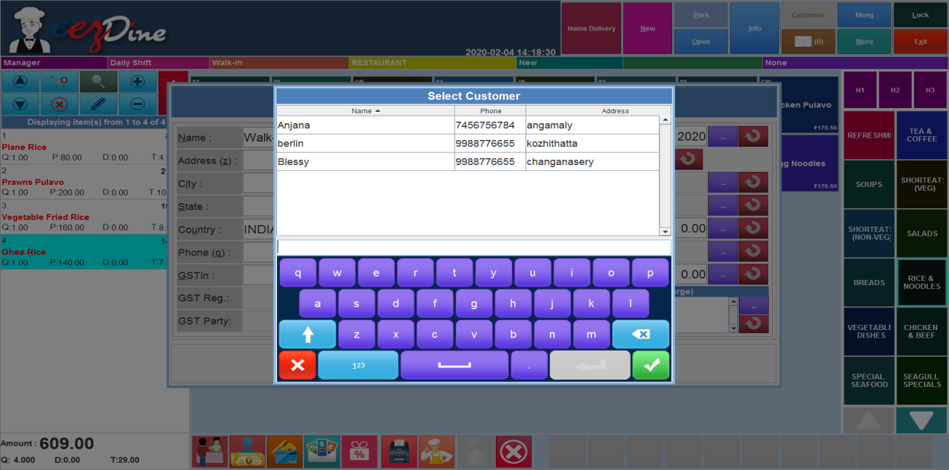

Fig: Customer List

If you select the name of the customer from the list, then auto populate the fields such as address, city, state, country and phone number. Then enter the GST number, then select the delivery date, time. Then select the proper option from the order by medium field from the list by clicking the button on the right side of the field. There are four mediums used in this system. Phone, Direct, Mail and EBS. when we click the button, popup the list as shown below.

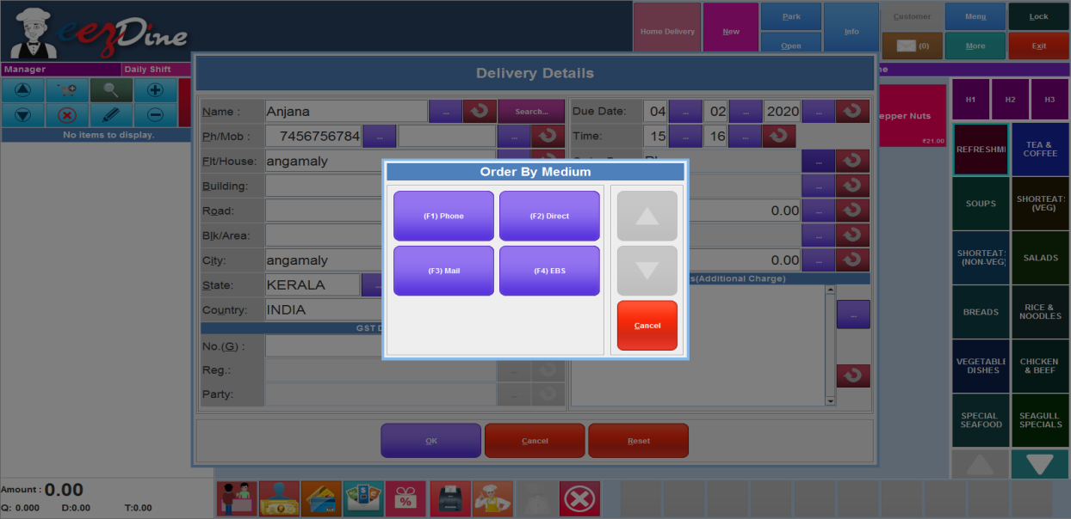

Fig: Order By Medium List

Phone meant that the customer ordered the food by a phone call, then the Direct meant that the walkin customers. Mail meant that the customer ordered the food by sending mail. Then the EBS is a system used in the shop like swiggy, uber eats etc. the order placed by the customer through this application.

Select the medium from the list. If the customer paid advance amount fill the column advance then select the payment mode by clicking the button on the right corner of the Pay. Mode field. When clicking the button popup the list of payment modes supported in this system as shown below.

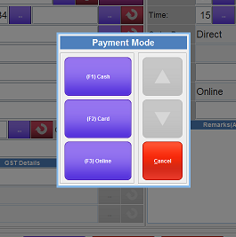

Fig: Payment Mode List

Then if you want to add any remarks just add it in the remarks column. Then click the OK button. Then select the items as per the customer order then park the order to the kitchen.

###### **2.7.1.1.3 Table Service**

Then the Table Service means food ordered by the customer at the table and served to the customer’s table by the waiters. We want to take a new order in the table service, first we click the service button and select the table service then popup a new window for the table service as shown below.

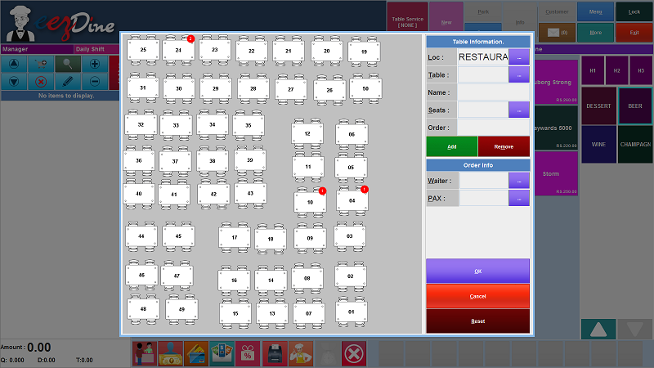

Fig: Table service

The dialog box shown above has three sections table information, order information and the table view as per the tables arranged in the shop. First we want to fill the table information it is mandatory. There are five fields such as Loc, Table, Name, Seats and Order. Loc means location of the table, when we click the button on the right side of the Loc field, popup a list of locations as shown below. Then select the location we want. Then the location is updated in the field.

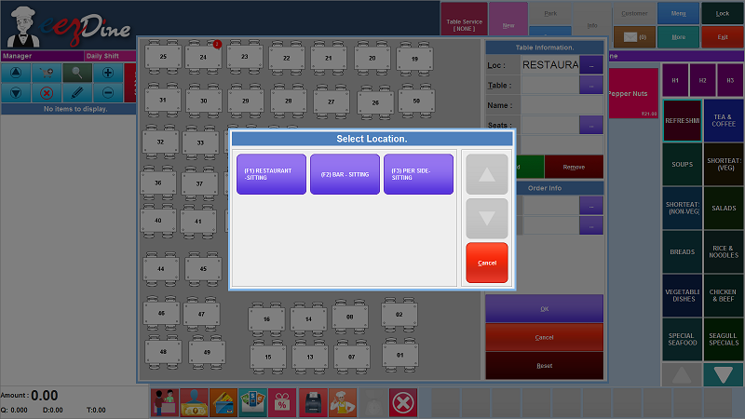

Fig: Location list

Then next we have to select the table number. Click the button on the right corner of the table field, popup a list as shown below.

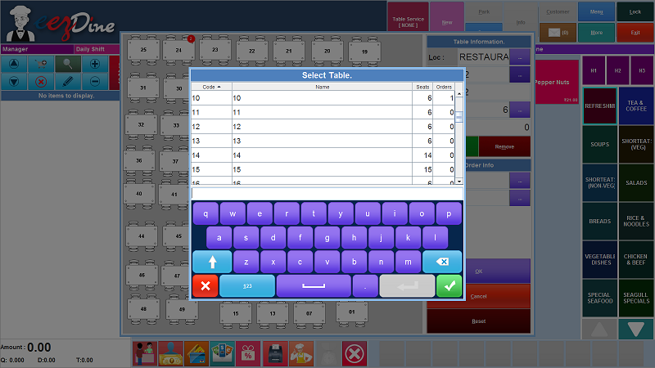

Fig : Table list

Select the unreserved table number then click the tick mark shown in the window at the right bottom corner. We can directly select the table from the table view shown in the figure(table service), then the fields are auto populated after selecting the table number as shown below.

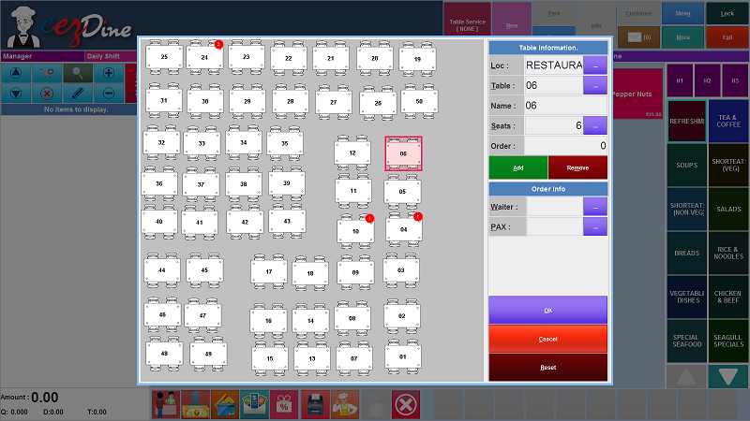

Fig: table information auto populated

Then click the Add button to add the table information in the order. The remove button used to remove the selection of table, if there is any incorrect entry.

Then fill the order information, fill in the name of the waiter who serves the table. Click the button shown on the right corner of the waiter field. Display the list of waiters working in the shop as shown below.

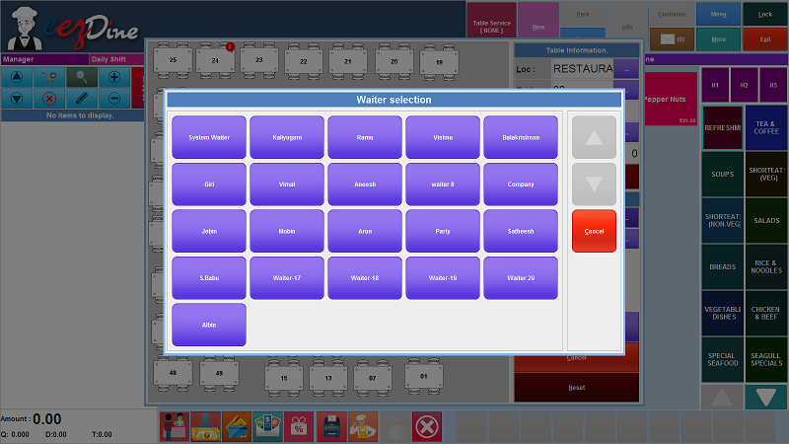

Fig: Waiters list

When we select the waiter name the fields are auto populated, and then click the OK button. The order entering the screen will be shown. Then we can select the items as per the customer order. There are many item class lists on the right side of the window. We can select the item class we want then show the list of the items included in the item class as shown below.

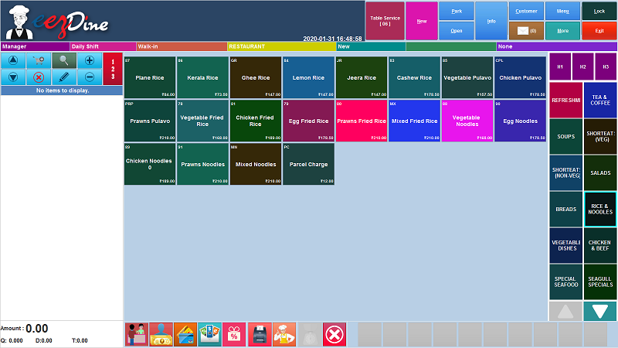

Fig: Item list

We can easily select the items ordered by the customer from the screen. The selected items will be shown on the left side of the screen with price details and the total price will be shown in the bottom left corner of the screen as shown below.

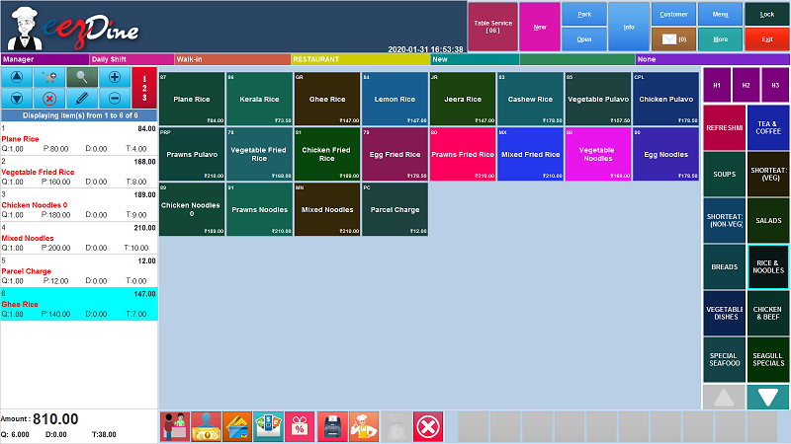

Fig: ordered list

Then we can park the order to the kitchen by clicking the Park button shown in the top panel and make a payment using the payment button to close the order.

###### **2.7.1.1.4 Sales Order Service**

Sales Order service is the same as the home delivery service. Sales order service is used for advance orders from the customers for parties, functions etc. When we select the sales order service, popup a window as same as the home delivery service to enter the customer details as shown below.

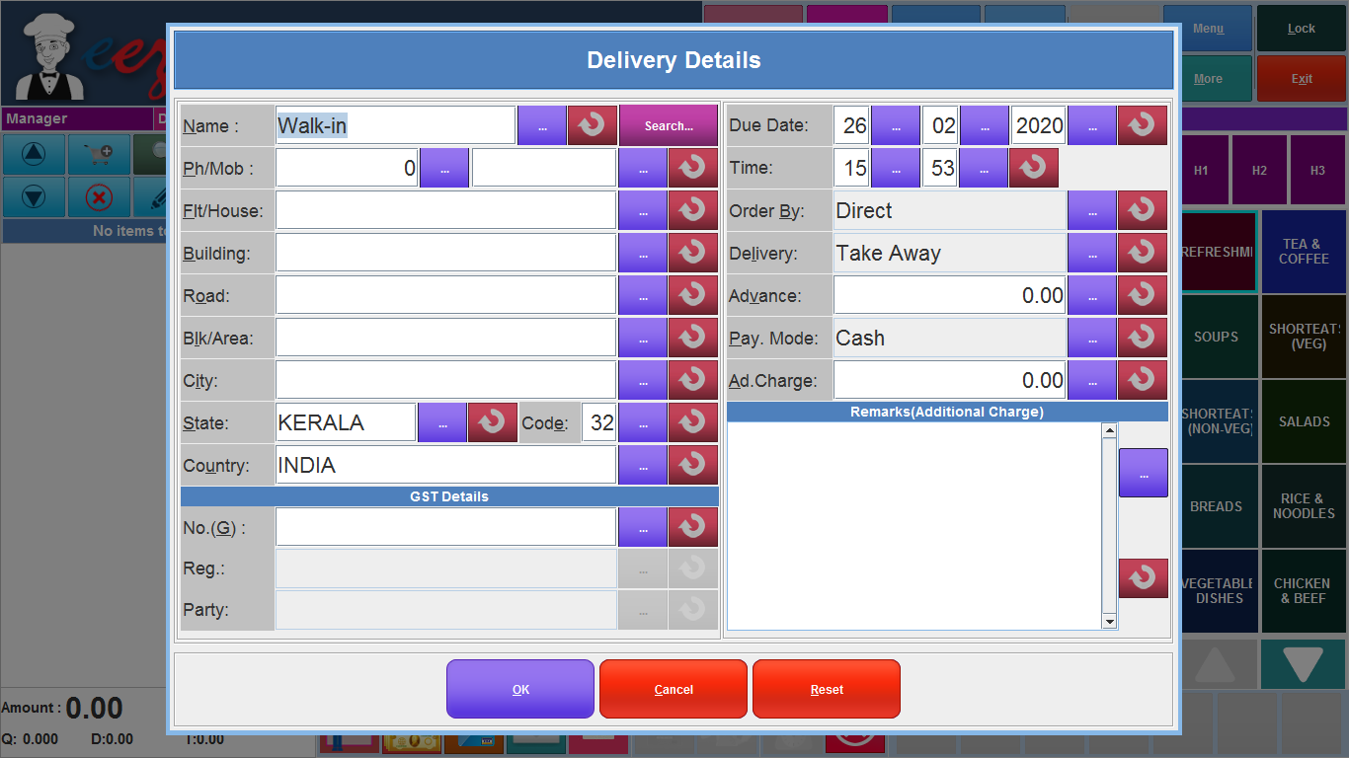

Fig: Sale Order Service

The window used to enter the details of the customer and the delivery date and time and the advance amount details. Then enter the details and click the OK button. Then select the items as per the customer order and Click the park button. If we want to make payment in the parked sales order, click the open button and select the order and make the payment by clicking the payment button. If the customer gives any advance amount, the given amount is reduced and calculate the balance amount and make the payment. The Sales order service is used for bulk orders and home delivery is not commonly used in sales order service.

###### **2.7.1.1.5 Wholesale Service**

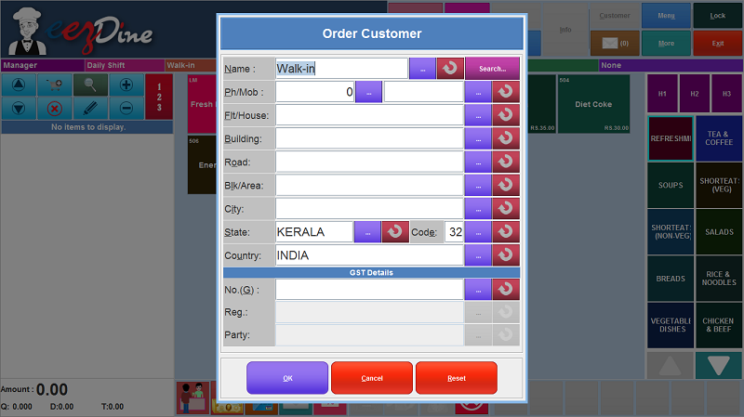

Fig:Wholesale service

Wholesale service is used only for the franchise of the shop. We can set the wholesale price of every item in the server and when we select the wholesale service, open the window shown above. Enter the details of the customer and click the OK button. Then select the items as per the customer order and click the quick payment button or standard payment button to make the payment. Then a popup a window as shown below to enter the driver details and vehicle details as shown below.

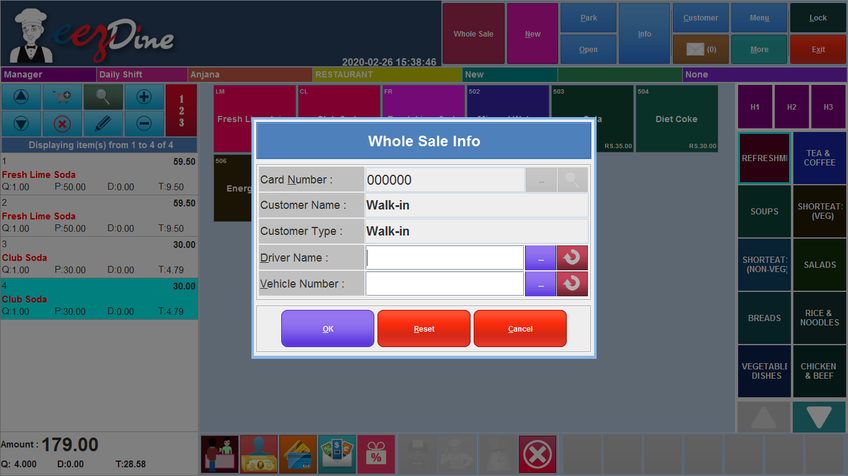

Fig: wholeSale Info

Enter the driver name and vehicle number then click the OK button, then popup the price details and click the Done button to complete the payment.

##### **2.7.1.2 New Button**



Fig: New Button

The New button used to place the new order. There are three services provided in the shop, Take Away, Home Delivery and Table Service. Then place a new order in Take Away Service, click the New button, then select the items as per the customer order then park the order to the kitchen by clicking the park button.

Then place a new order in the Home Delivery Service, click the new button, then popup a new window shown in fig: Delivery Details. Then fill the window as mentioned above in **2.7.1.1.2.** Then select the items as per the customer order and park the order.

Then the next service is table service. We want to place an order in table service, first change the service mode as Table Service, and then next steps are mentioned in 2.7.1.1.3**.**

##### **2.7.1.3 Park Button**

Park Button is used to park the order to the kitchen. Here a Park button shown in the top panel as shown below



Fig: Park Button

When we take a new order in Take Away service, select the items as per the customer order then click the Park button, then popup a dialog box as shown below.

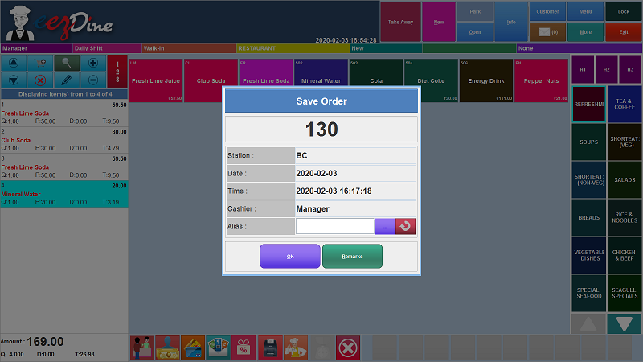

Fig: Save Order dialog Box

Enter the Name of the customer in the field named Alias and if we want to make any remarks, click the Remark button then popup a new window to add the remarks as shown below.

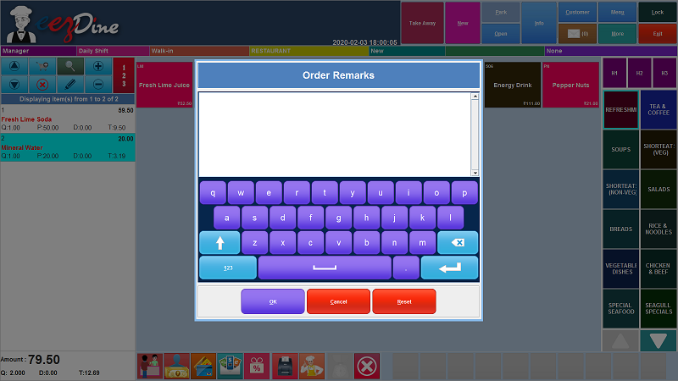

Fig: Order Remarks

Then click the OK button. Then popup an alert box to ask to give kitchen receipt print to the kitchen, Click the OK button. Then an alert box is shown after the order is parked as shown below.

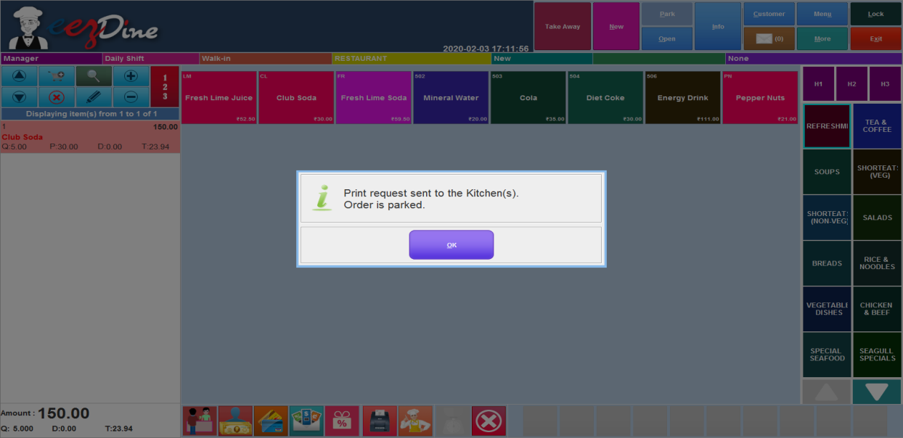

Fig: Message alert after park the order

If you want to park an order in Home delivery service, change the service button as Home Delivery, then select the items as per the customer order then click the Park button, and then show an message box as shown below.

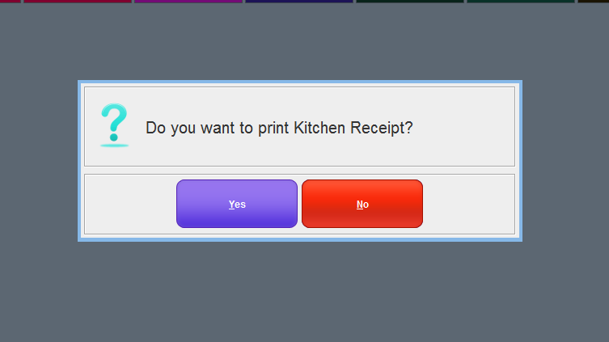

Fig: Message Box

Click the Yes button to give the kitchen Print. Then popup an alert box to inform you that the order is placed.

If you want to park a new order in table service, select the service as table service then select the table and the waiter as above mentioned in the table service. Then select the items as per the customer order and click the park button. Then popup a message box the same as the home delivery service for the confirmation of kitchen print.

**2.7.1.4 Open Button**



Fig: Open Button

Open Button is used to open the opened orders list. If you want to open an opened order click the open button from the top panel, then popup a list of opened orders as shown below.

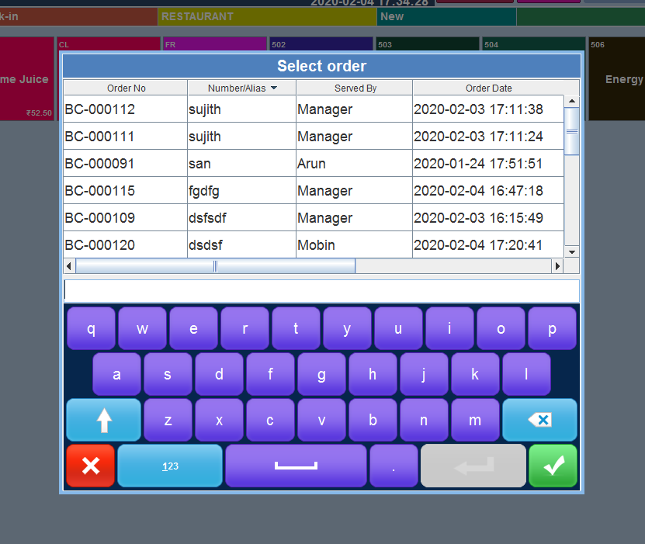

Fig: Order List

Select the order if you want, then click the tick mark on the bottom corner of the window. Then open the order as shown below.

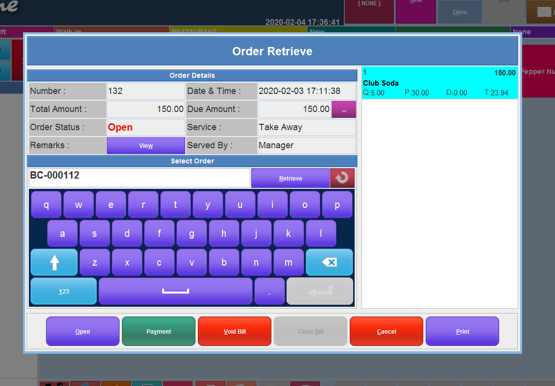

##### 

##### 

##### 

##### 

##### 

##### 

Fig:Order Retrieve

|  |  |
| --- | --- |
| **Field Name** | **Description** |
| Number | Order Number. |
| Total Amount | Total amount wanted to be paid by the customer. |
| Order Status | Current Status of the order, if the customer paid the bill the status shown as Closed, otherwise it shown as Open. |
| Remarks | If the customer adds any remarks at the time of order placed, it will be shown by clicking the view button in the field. |
| Date & Time | Order placed Date and Time |
| Due Amount | Balance Amount paid by the customer. |
| Service | Type of service (Take Away, Home Delivery, Table Service) |
| Served By | Name of the Waiter |

##### These are the fields shown in the above window. We can see the orders details from these fields. There are five buttons shown in the window: Open, Payment, Void Bill, Cancel and Print. Open Button is used to open the order. When we click the open button, the order is opened in the order entry window as shown below.

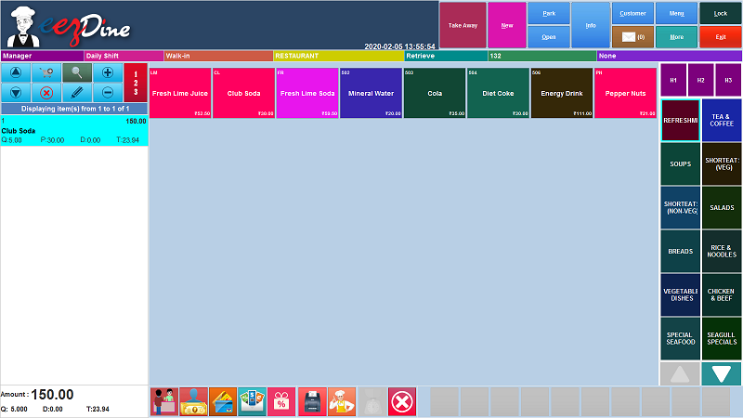

##### 

##### 

##### 

##### 

##### 

##### 

##### 

##### Fig: Order entry window

We can add more items from here or edit the order details from here. Then the Payment button is used to make payment of the order. When we click the payment button, popup a list of payment modes as shown below.

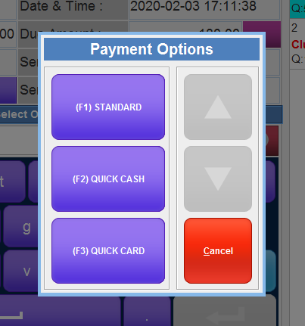

Fig: Payment options

Payment Options are mainly three types we used in this system. Standard, Quick Cash and Quick Card. Standard option is used for the standardized way of payment mode used in the system, then the quick cash and quick card is used to ease the payment. The Void bill option is used to delete the order. Cancel button used to cancel the attempt. Then the print option is used to take print. There are three options in print: Bill receipt, Kitchen Tickets, Barcode labels. If we want the bill receipt select the bill receipt option. If you want to take the kitchen print again, select the kitchen ticket option. And the barcode labels means; if the customer wants an item more than numbers we can add the barcode with the item pack. At a time we can print barcodes more than one print by using these barcode labels.

**2.7.1.5 Info Button**



Fig: Info Button

The Info button is used to take the information of the current order. If a new order is placed in any services, first we select the service then click the new button for a new order then add the items as per the customer need. The info button is used to take the information of current order, if we add the items in the order, then select the info button then popup a new window as shown below.

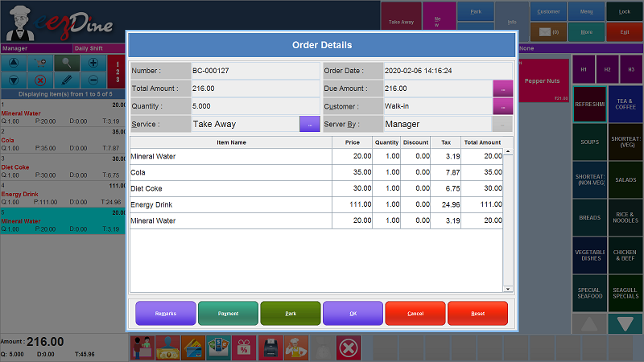

Fig: Order details

Here we can edit the order details in the window; here we can see the details of the current order. In this window, we can edit the service by clicking the button shown in the service field and we can change the customer details by clicking the button on the right corner of the customer field.

Here we can add remarks by clicking the remark button on the bottom of the window. Then the payment button is used to make payment. Park button is used to park the order to the kitchen. Reset button is used to reset the order details whether you have changed any details. The cancel button used to exit from this window. If you see or make change the order details then the OK button.

##### **2.7.1.6 Customer Button**



Fig: Customer Button

The customer button is used to add the customer details. When we click the customer button, popup a new window to enter customer details as shown below.

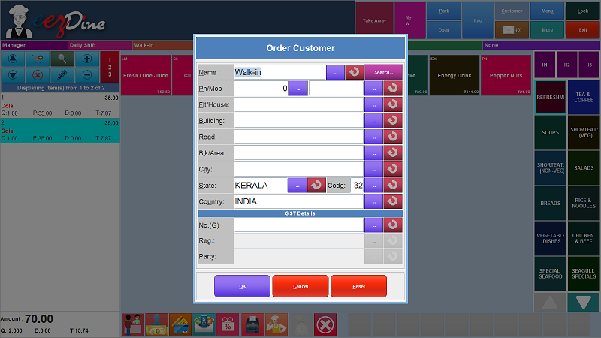

Fig: Order Customer

##### Here we can add the customer details through this window. The walkin customer is the default customer. We can also add the registered customers from the list by clicking the search button seen in this window. By clicking the search button, the list of registered customers will be shown in a list and we can select the customer from the list and then the details will be auto populated in the fields. Otherwise if you want a new customer enter the details in the appropriate columns then click the OK button.

##### **2.7.1.7 Message Button**



Fig: Message Button

The messages sent by the admin are seen by clicking the message button. Any data update done by admin in the server or any messages want to pass the shops and POS terminal system, the admin can send a message in server then the POS system will notify the notification as flash message as shown below.

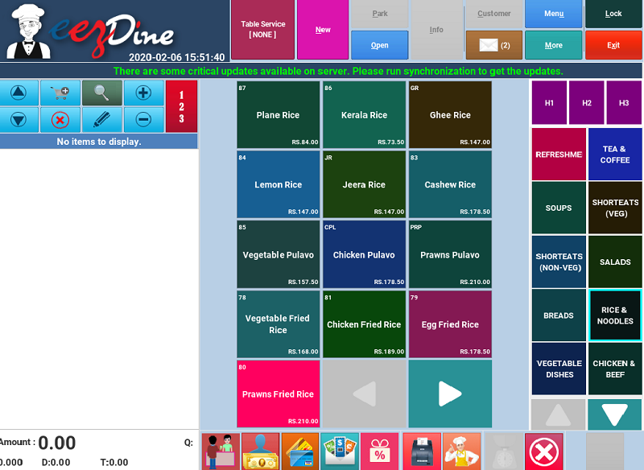

Fig: Flash Message

The flash message on the message panel. If the notification is raised we have to synchronize the system to update the data or message. Click the exit button to exit from the window and click the Sync Now button to synchronize the message or data update done by the admin. Then click the order entry button, the order entry window will open and message update is seen in the window. Click the message button, popup the message box as shown below.

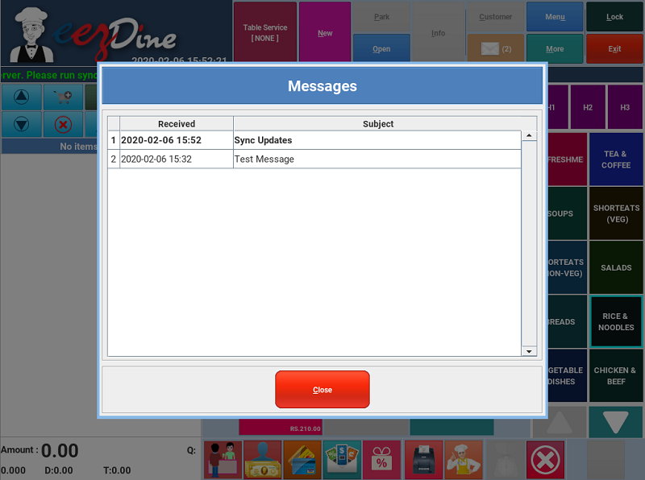

Fig: Message List

The new messages are seen in the list in bold letterings. Double click the message to read the message, and then the message will be shown as below.

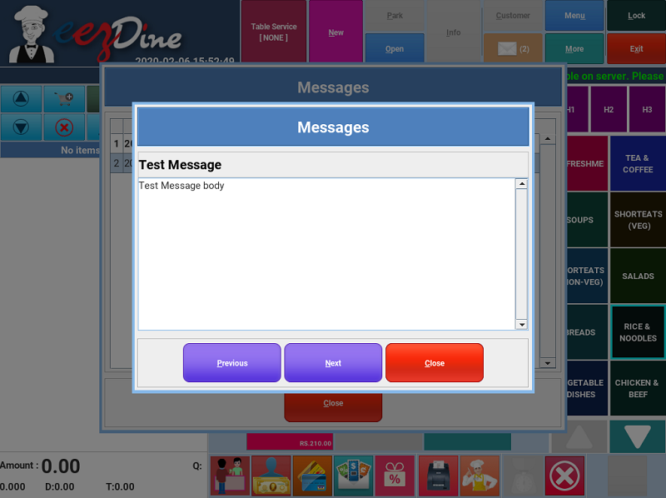

Fig: Message

The next button is used to see the next message without closing the window and the previous button is used to see the previous message from the list.

##### **2.7.1.8 Menu Button**



Fig: Menu Button

The menu button is used to change the menu. When we click the menu button, popup a new window with the list of menu added in the shop as shown below.

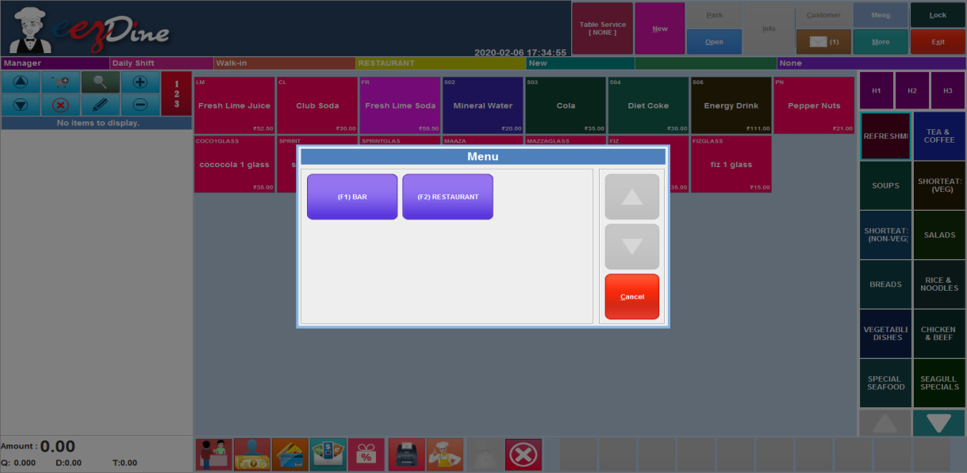

Fig: Menu List

Here are two menus listed in the window. When we selected the Bar menu the food items listed in the order entry window are under the Bar menu otherwise Restaurant Menu. The item class list will change as per the menu selected.

##### **2.7.1.9 More Button**



Fig: More Button

The More Button is used for direct access of other functionalities used in this system. When we click the More button, popup a list of functionalities used in this system as shown below.

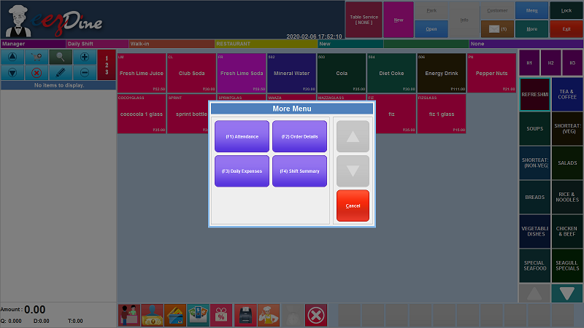

Fig: More Menu list

The More menus consist of four functionalities provided in this system such as Attendance, Order Details, Daily Expenses, and Shift Summary.

Attendance button is used for entering the attendance of the employees working in the shop as a register. The employees should enter the IN and OUT time through this POS terminal.

Order Details is used to see the overall order details.

Daily Expenses button is used to enter the money spent for the other purposes.

Shift Summary Button is used for taking the shift summary report.(this is showing expense details)

##### **2.7.1.10 Lock Button**



Fig: Lock Button

Lock button is used to lock the screen. If we need an emergency situation to go, we can use this lock button to lock the screen. This time no one can enter the screen to take an order or whatever else. The authentication is needed to unlock the screen. When we click the lock button, popup a new window as shown below.

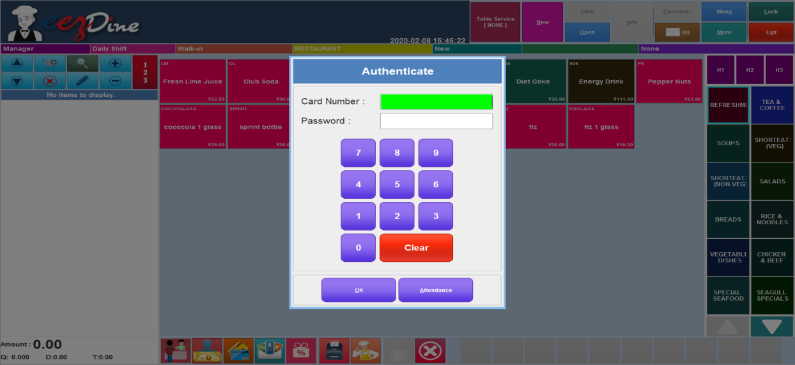

##### 

##### 

##### 

Fig: Locked screen

The window has no cancel button. We can only close the window by entering the valid card number and password. Then the attendance button is used to enter the attendance of the employees. When we lock the screen, any one of the employees want to enter the attendance they can use the attendance button to enter the attendance.

##### **2.7.1.11 Exit Button**

Fig: Exit Button

Exit button used to exit from the order entry window.

#### **2.7.2 Message Panel**

Fig: Message Panel

The message panel is used for showing the details of the order. There are seven columns used for showing the details. The first column used to display the name of the person who logged in the POS system. Then the next column used for the user logged in which shift. The third column used for showing the customer name. The fourth column used for showing the name of the menu the customer chose, here we have two menu bars and a restaurant. If we select the Bar option from the menu button, then the column value will be Bar otherwise Restaurant. The fifth column shows the order status. When we place a new order, this column value is New otherwise if we open a parked order the column value is Retrieve. The sixth column is used to show the Order No.. then the last column is used to display the offer details. If the shop will have any festival offers or any kind of offers given by the day. The offer name is shown in this field.

#### **2.7.3 Order List Panel**

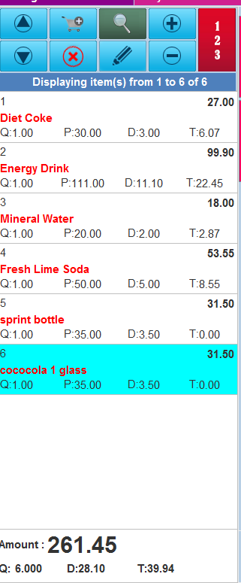

Fig: Order List Panel

Order list panel is used to manage the items selected in the order. The top portion of the order list panel is used to manage the selected items. The two up and down arrow marks work as pagination on the list. If we select more items we can’t see the list fully in this panel, so this arrow marks will act as pagination and give the full list page by page.

The Shopping cart plus button is used to add items in the order. When we click the shopping cart button a list of items will be shown as below.

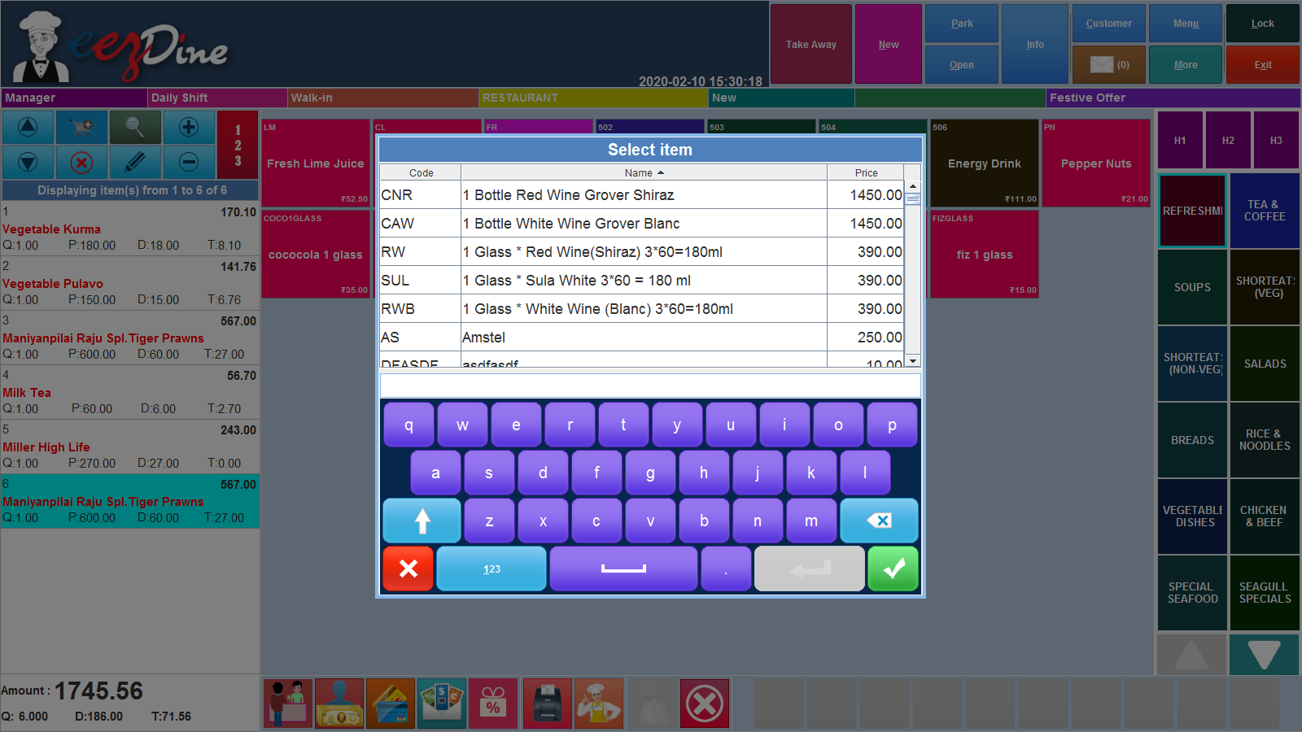

Fig: Item List

We can select the items from the list and add it to the order list. And also we can enter the name of the item in the blank field to search for the item name from the list. After adding the items close the window by clicking the Red Cross button.

The red rounded cross button is used to delete the item from the list. The lens button is used for searching the item from the selected list of items. When we click the lens button, a window will be shown as below.

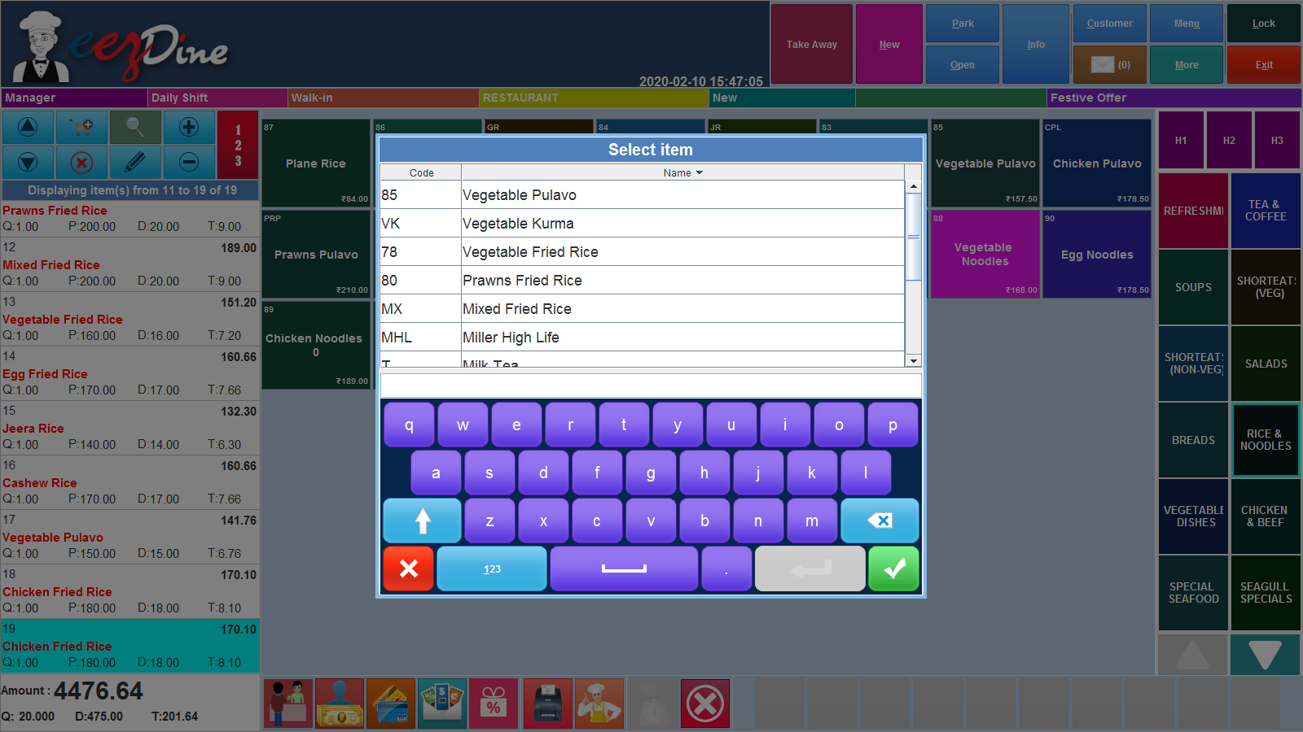

Fig : Selected item list

This window will show the list of the selected items in the order. We can easily search the items from the list by entering the name of the item in the field shown in the window.

The Pen button is used to edit the details of the item selected in the order. First we select the item we want to edit and then click the pen button to edit the item details. When we click the pen button, popup a window has shown as below.

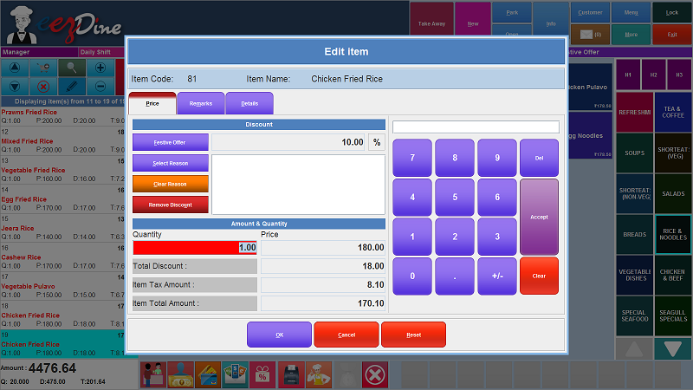

Fig: Edit Item Window

Top of the window we can see the item code and item name. Then there are three menu buttons: Price, Remarks and Details. The first one is the Price button; the window will open by default. The window is mainly two parts Discount, Amount and Quantity. The amount and quantity session shows the quantity, total discount, item tax amount and item total amount. We can change the quantity of the item by using the keyboard shown in the window. The discount session shows the discount details and we can add the discount by clicking the discount button from the window. If there is any special discount provided for any regular customers, we want to add the reason for the discount. For this click the select reason button to select the reason set by the admin in the server. Click the select reason button, popup a window with a list of discounts. Select the discount reason then auto populate the reason column. If we want to clear the reason, just click the clear reason button. The remove discount button used to remove the discount from the bill.

Then the remark menu shown in the window used to enter any remarks in the order. Click the remarks button, change the window as shown below.

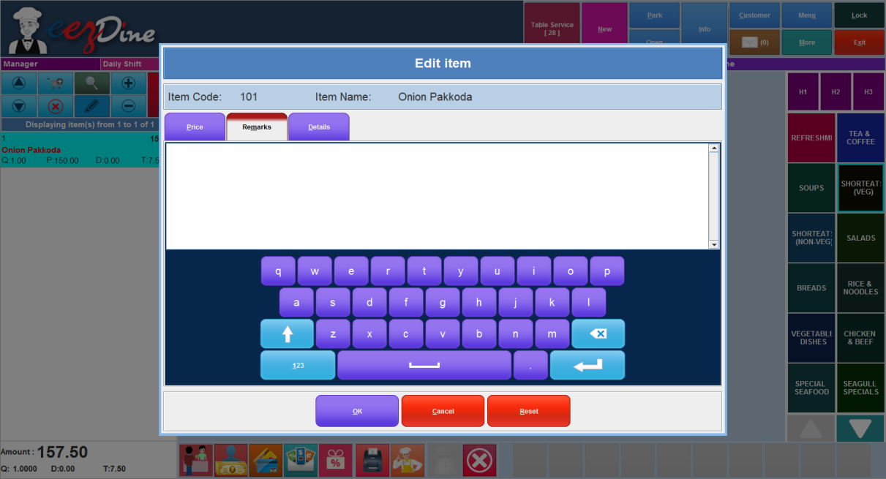

Fig: Remark entry window

We can add the remarks here. We can also use the keypad shown in the window.

Then the Details button used to see the details of the selected item. Click the details button, it details such as item code, item name, alternate name, item class name, price and remarks.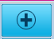

Then the plus button shown in the ordered item list is used to change the quantity of the item. First we select the item wanted to change the quantity, then click the plus button to increase the number of the quantity one by one.

Then the minus button shown in the ordered item list panel is used to decrease the quantity of the item. First we select the item wanted to decrease the quantity, then click the minus button to decrease the quantity of the item one by one.

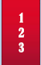Then the button shown like is the keypad for entering the quantity. Then the list shown below is the selected items as per the order from the customer. Then the bottom part of the ordered item list panel shows the total price details of the items selected. Total price, total number of items, total discount amount and total tax amount are displayed in this part. The waiter selects the item one by one, and the price details will be added one by one.

#### **2.7.4 Item List Panel**

The item list panel shows the list of items as per the item class selected from the item class panel. The list is shown below.

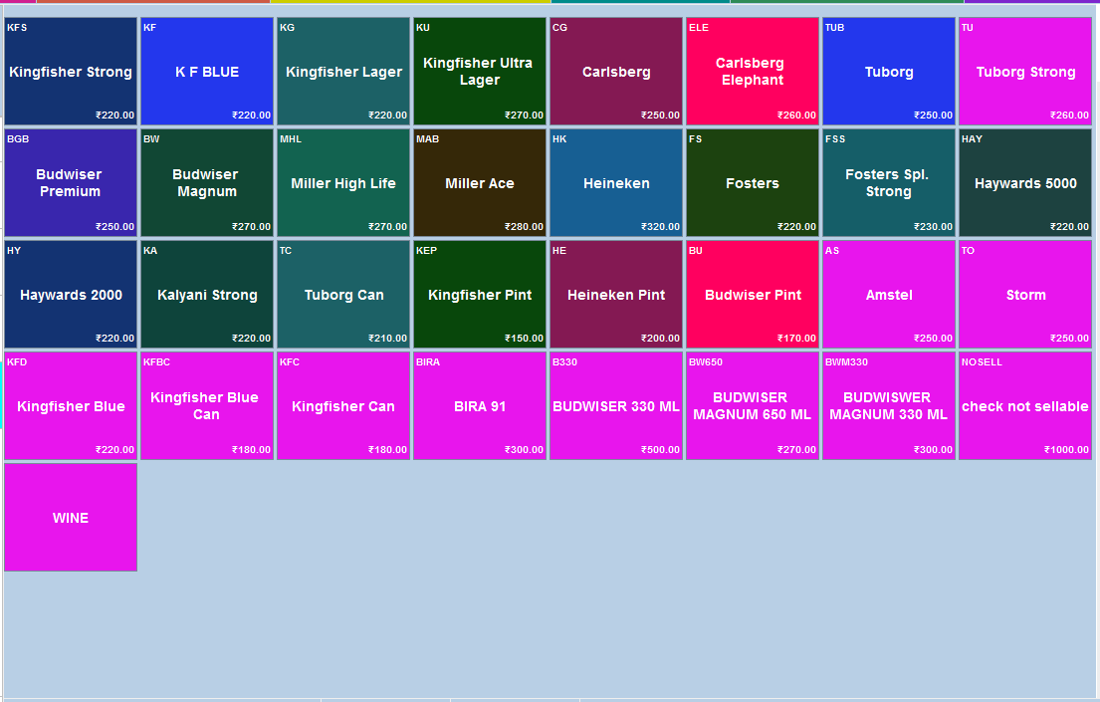

Fig: Item List Panel

We can select the item from the list and we can also see the price, item code and item name from the list. We can easily select the items from this panel and add them to the ordered list panel. First we select the item class from the item class list panel then the items under the selected class will be shown in the item list panel.

#### **2.7.5 Item Class List Panel**

#### The item class list panel is shown on the right side of the window. The items are classified into different groups such as wine, dessert, refreshment, soup etc. Each group considered as an item class and every item class consists of many items. The item list panel shows the items included in the selected item class. The item class panel as shown below.

#### 

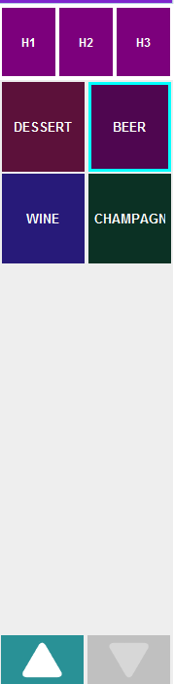

Fig: Item Class Panel

The H1, H2 and H3 are the category list with respect to the fast moving items in the shop. We can set the fast moving items in morning, evening or night time. The admin can set the items as per the moving in particular time. Suppose we have some items moving more in morning and some items moving more in evening time. Then we can set the items in the morning section in H1 and the H2 for evening time. Then we can easily see the item list by clicking the H1 and H2 button from the item class panel.

Then the item class list is listed below the H1,H2 and H3 button. Then the arrow button used to scroll the list up and down.

#### **2.7.6 Bottom Panel**

Fig: Bottom Panel

The bottom panel is used for ease of use. We can easily access the most used functionalities from this panel. There are ten buttons shown in the figure above.

###### **2.7.6.1 Quick Payment**

The first button is used for a quick payment method. When the cashier was busy making payments of orders, they can easily make payment by using this button. When we click the quick payment button, popup a list of payment options as shown below.

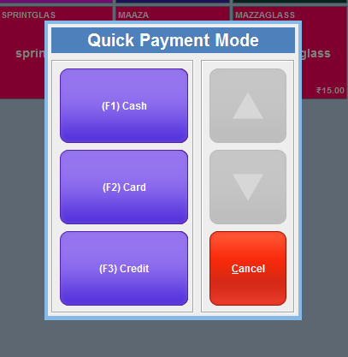

Fig: Quick Payment Mode

There are three modes of payment listed: Cash, Card and Credit. When the customer makes payment by cash, click the Cash button for quick payment. The bill was printed and the payment will be done in simple clicks. The Card Button is used for Card payment. When we click the card button, ask for bill print and payment will be done. The Credit Button is used only for credit customers. The payment will be done in simple clicks and we can fastly do the payments by using these buttons. The arrow button shown in the list is used for scroll up and down and the cancel button used for cancelling the operation.

###### 

###### **2.7.6.2 Standard Payment**

The second button is the standard payment button.When we select the standard payment mode, popup a payment window as shown below.

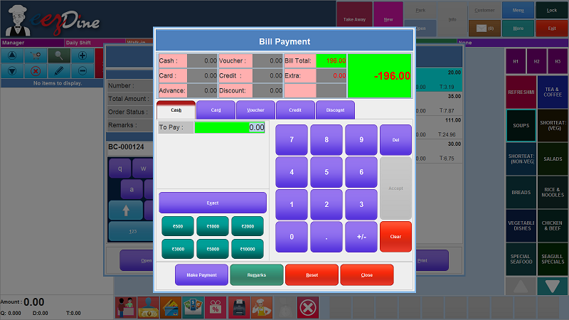

##### 

Fig: Standard Payment mode

The payment modes are mainly four types: Cash, Card, Voucher and Credit. If the customer pays the bill by cash, then select the Cash option. Here you can enter the amount using the keyboard shown in the window. If the customer gives the exact amount then click the exact button directly enter the exact amount. If the customer gives the amount seen in the window as button (500, 1000, 2000, 3000, 5000, 10000) then click the button which we needed directly and the balance amount will show the top right corner of the window. Click the Make Payment button to make the payment, then popup a message box for the confirmation of bill print. If you want the bill receipt click Yes Button then show the balance payable amount details.

If the customer pays the bill by card, select the card option then the window will change for the card payment as shown below.

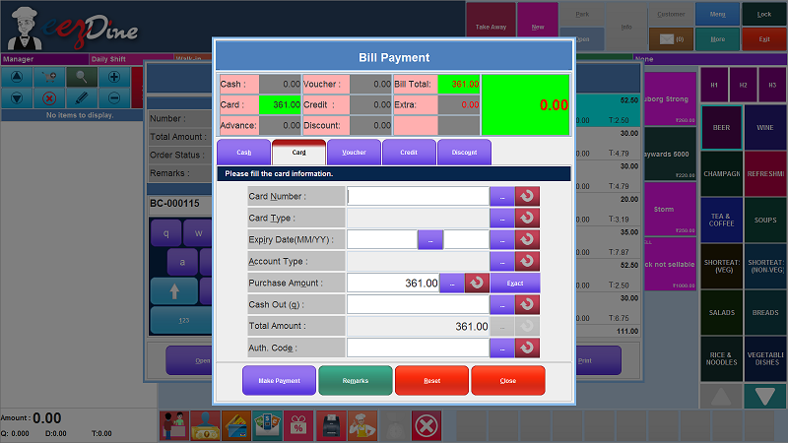

Fig: Card Payment

Here we can see the window to fill the card information. Enter the 16 digit card number in the card number field. Select the card type from the list. Enter the expiry date of the atm card as per the column. Select the account type from the list. Here we allowed the three types of bank accounts. Select the account type then enter the purchase amount. If the customer gives the exact amount, then click the exact button directly to enter the cash amount. Cash out field is used for the customer's purpose. If the customer wants to withdraw cash from the account through this payment enter the cash amount they want then the cashier transfer the cash through card and gives the amount to the customers by cash. Then enter the authentication code and then click the make payment button. Then popup a message box to confirm the print bill receipt, if the customer wants the bill receipt click the yes button and then balance payable amount details will be shown in a dialog box. If we want to reprint the bill receipt click the reprint option otherwise click the Done button. Then the payment will be completed.

If the customer uses any vouchers for bill payment select the voucher option, the window will change for the voucher payment mode as shown below.

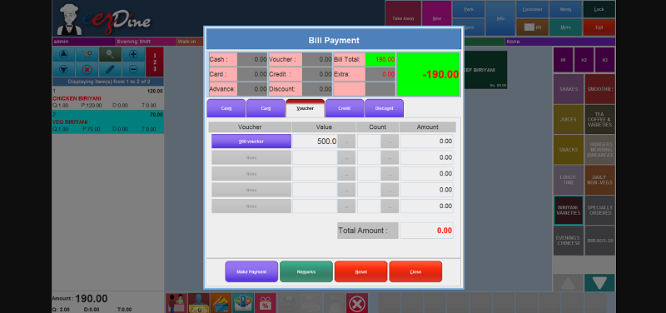

Fig: Voucher Mode Payment

The voucher payment windows show the list of vouchers added by the shop. If the customer has any vouchers, then add the voucher by selecting the voucher from the list and make the payment. If the amount is less than the voucher amount the balance cash will show after the payment. If the amount is greater than the voucher amount then the balance cash will add the cash option then make the payment.

The credit payment option is used only for the registered customers. If the credit option is selected the window will change for the credit payment mode as shown below.

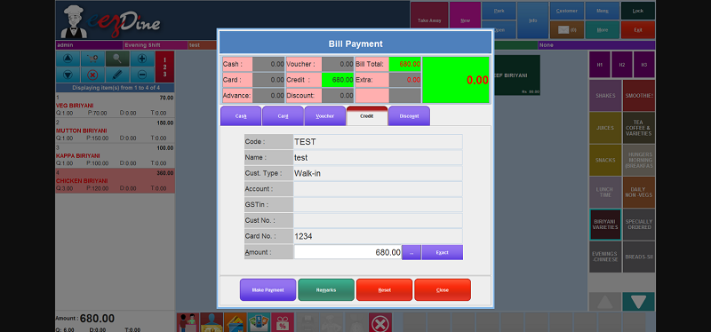

Fig: Credit Payment Mode

The new order is placed for registered customers click the new button for new order and selects the customer from the list shown by clicking the customer button from the top panel. Then select the credit payment methods for making payment the amount value will auto populated and click the Make Payment option then the balance payable details will be shown in a dialog box. Click the reprint option otherwise done option.

The discount will be added by clicking the discount button. Click the discount button, and the window will be shown as below.

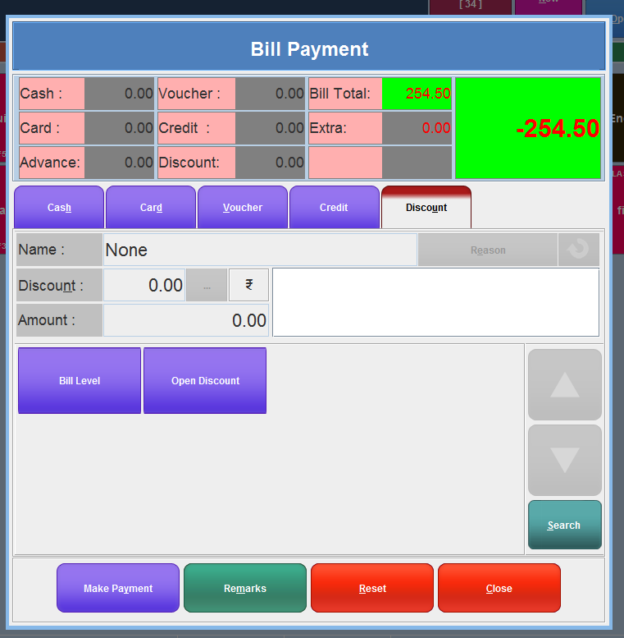

Fig:Discount window

If the order has any discount, we can add the discount by clicking the discount button from the window. When we click the discount button, change the window as shown above and the list of discount given by the shop is seen in the list otherwise we can search the discount by clicking the search button seen in the right side of the list. Select the discount we want and the details will be auto populated in the fields. Then we can add the reason by clicking the reason button shown in the window. List of reasons added by the admin will be shown and select any one of the reasons. If we want to reset all the setting click the reset button. If we want to add remarks in the order click the remark button and add the remarks and click Ok button. After adding the payment details, click the make payment button to make payment. Popup a message to confirm the print option, then popup the payment details in a window.

###### **2.7.6.3 Card Payment**

The card payment button used to directly access the card payment mode.

###### **2.7.6.4 Voucher Payment**

The voucher button is used to directly access the voucher payment mode.

###### **2.7.6.5 Split Payment**

Split payment method combines several payment methods in one purchase transaction. This means a shopper can buy an item with a credit card, a voucher and cash or any combination of payment methods; on a single transaction. In some situations, a group of people came to the shop and ordered many items in a single order. Then they ask us to pay the bill in seperate. Here we use this split payment mode for split the bill into two or more bills as per the customer request. And also we can add a deposit amount in advance for the purchase. We can split the bill in many ways. We can split the bill as per number of customers, items, percentage of amount and table or seat. When we place a new order select the service and place the order. If the customer asks for split payment open the order and click the split payment button shown in the bottom panel. Then popup a new window as shown below for the split payment.

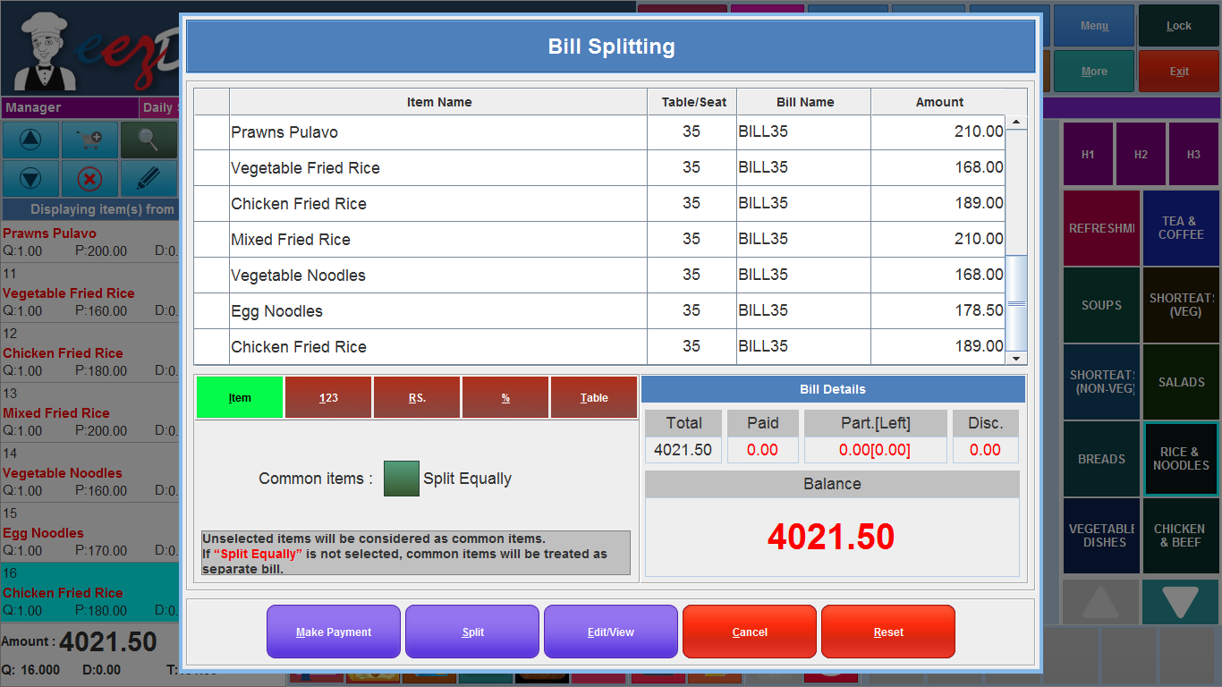

Fig:Split Payment mode

###### The window shows the split payment. Here we can see that the items ordered are listed in the top portion of the window with the item price. The left corner shows the splitting options: item wise split, number of customers, amount wise split, percentage wise split, table wise split.

###### **2.7.6.5.1 Item wise split**

###### If you want to split the bill in item wise select the wise split and select the items from the list shown above in the window. Then click the split button, the split window is popup as shown below.

###### 

Fig: edit split window

Then enter the split name as the customer name (the person who is gonna pay the bill). And you can see the total number of items and the total amount you want to pay. Then click the OK button. The split is done for the first customer. Then the list is changed as below.

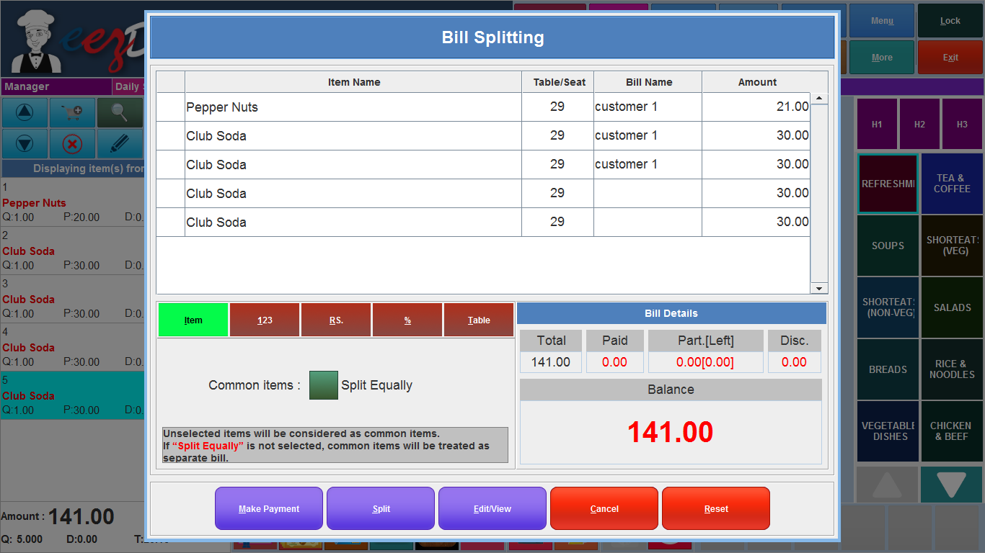

Fig:bill splitting

The split name is shown in the list in the appropriate items. Then again select the items to create another split the same as the previous way. This way we can split the bill as per the items in the order. Then you can see the name of the split in the list then click the make payment button to make the payment. When we click the make payment button, popup the list of splitted bills in the window as shown below.

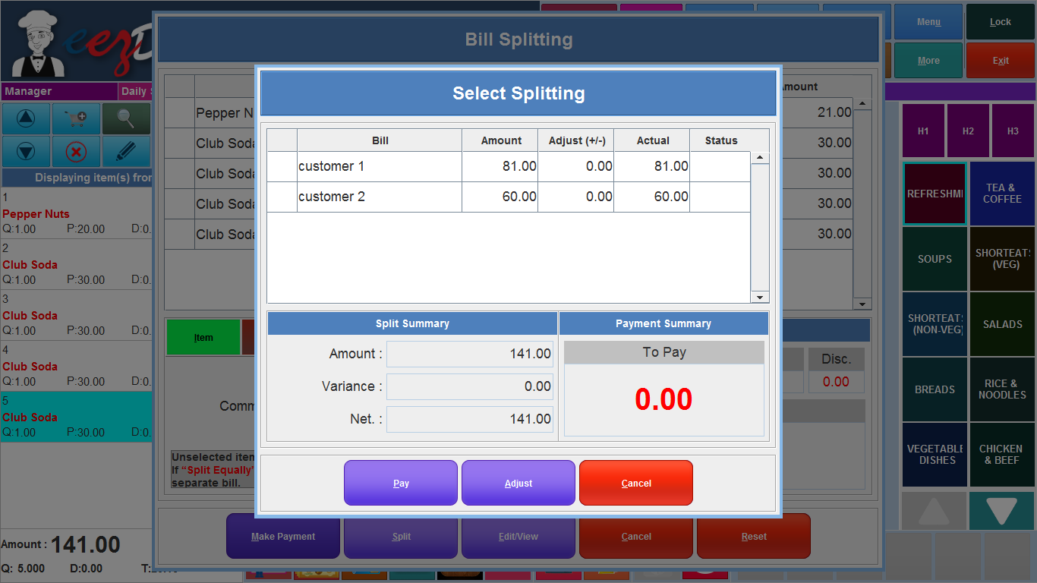

Fig: select splittings window for make payment

Select the bill and make payment then click the pay button to make the payment. Then the standard payment window will open and make the payment. In some cases if the customer wants to make any adjustments in the bill, then select the bill want to adjust and click the adjust button from the window. Popup a adjust amount box as shown below.

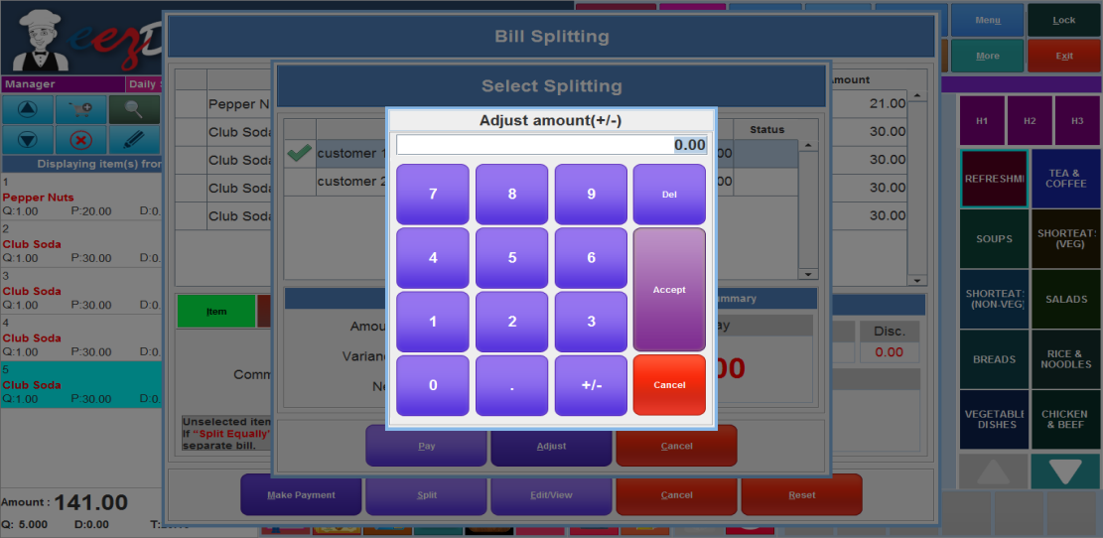

Fig:amount adjust

Enter the amount you want to adjust. If the customer wants to reduce the bill amount, enter the amount want to reduce as like -20 (minus sign must be put before the number). Then adjust the same amount in the other bill in the same order. If you want to add the amount just enter the amount in the amount adjust window. Then make the payment by clicking the make payment button from the window. If any item wants to split equally for everyone the common split option is selected. The unselected items are equally splitted for everybill.

###### **2.7.6.5.2 Person wise split**

In some cases, some people dine out with friends then they decide to pay for their own food and drink or split the bill so that everyone makes an equal contribution. In such situations they want to split the bill equally. Here we can split the bill equally for everyone. Open the order and click the split payment button from the bottom panel. Then select the person wise split option seen like 123 in the options. The window is shown below.

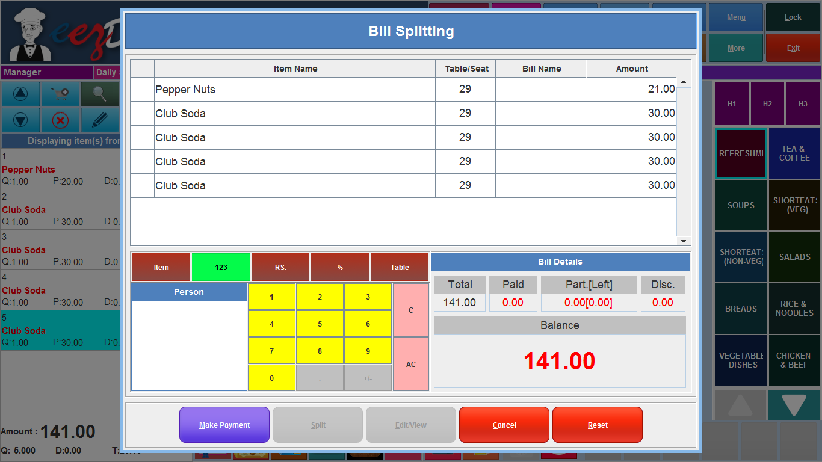

Fig: person wise split

Enter the number of people who want to split the bill in space. Then click the make payment button then the bill is splitted equally and the list is shown after clicking the make payment button as shown below.

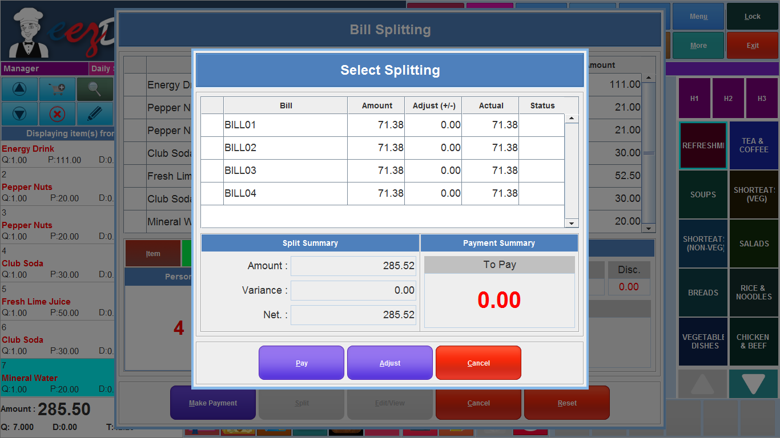

Fig: split list

Then select the bill and click the pay button to make payment. When we click the make payment button the standard payment window will open and make the payment. Adjust button used to adjust the bill amount if needed, as explained above.

###### **2.7.6.5.3 Percentage wise split**

In some situations, some of them dine out in groups and they want to pay the bill as per the percentage of the bill amount. They want to split the bill as per the percentage wise. Open the order and click the split payment button to split the bill and select the % sign seen from the window, and enter the percentage in the space given. The window is shown below.

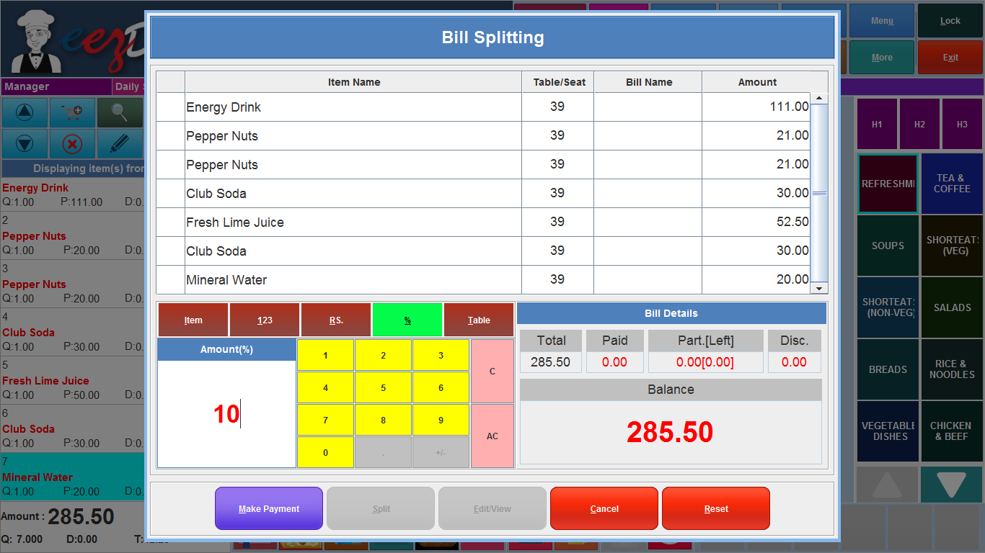

Fig: percentage wise split

**2.7.6.5.4 Table wise split**

In table wise split payment method, if the customers are sitting in two tables and share the food with each other and they ask to give separate bills for each table. In such cases we can split the bill table wise using this table wise splitting. Open the order and click the split payment button then select the table wise split option, two options are available for splitting . based on table and based on seats. If you want to split the bill table wise select the based on table option otherwise select based on seat then click the make payment button. Then popup the list of bills, select the bill you want to make payment and click the pay button. Then the standard payment window will open and make the payment. If you select the based on seat option and click the split button. Then the bill is splitted as per the table number then click the make payment button and list of two bills are shown then select the bill and make the payment. If the customer wants to make any update in the bill click the edit/view button to edit the bill. The table wise splitting window as shown below.

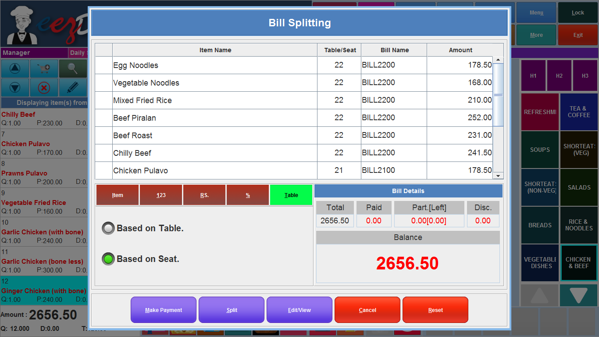

###### Fig: Table wise split

###### **2.7.6.6 Add Discount**

The discount button is used to add the discount directly to the order.

###### **2.7.6.7 Print Receipt**

The print button is used to print the receipt.

###### **2.7.6.8 Print to kitchen**

The print to kitchen button is used to give the print to the kitchen directly. We can give the print of the order list and newly added list of the same order also.

###### **2.7.6.9 Weighing machine**

The weighing machine button is used to enter the weight of the item. The weighing machine is connected with the POS system and the weight is measured and passed to the system. While making payment the price is calculated as per the quantity entered.

###### **2.7.6.10 Delete order**

The Cross button is used to void the bill or delete the order.

## **2.8 Shift Reports**

The shift report button is used to take print to the daily shift report. When we click the shift report button, popup a authentication window for user authentication. Enter the valid card number and password and click the OK button. Then a new window will open as shown below.

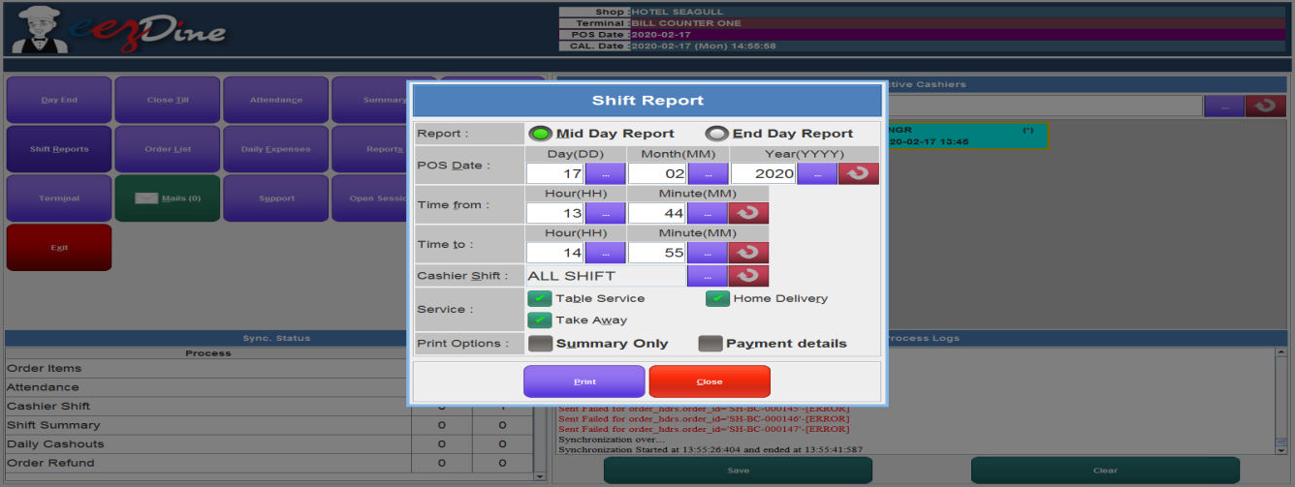

Fig: Shift Report(Midday Report)

Here we can take the MidDay Report and Day End Report. If we want a MidDay report, Select the Date of the report we want and enter the From time and To time. Then select the cashier shift from the list shown while clicking the button on the cashier shift field. Then select the services we want. Check the checkboxes and select the print option summary only or Payment details. If we want only the summary, select the summary only otherwise select the payment details. If we didn't select any one of these. It will automatically print the full payment details. Then click the print button to take print. If we want the Day End Report select the End Day report then the window is shown as below.

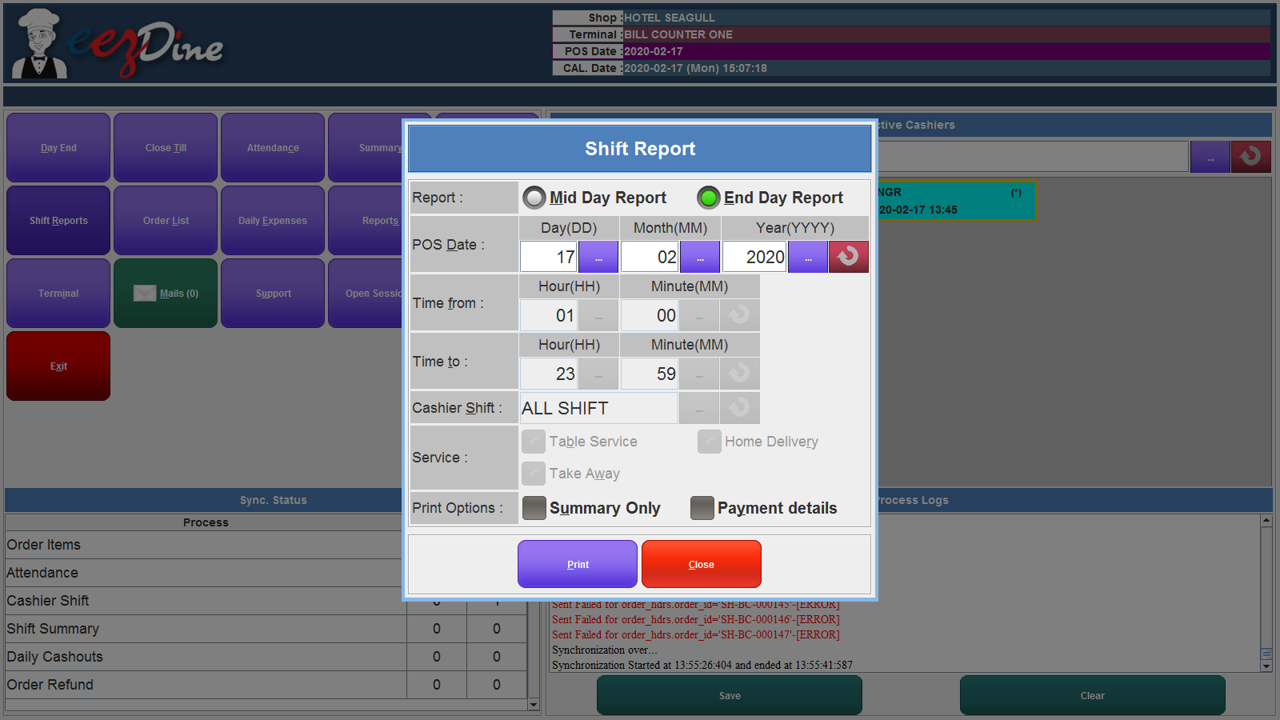

Fig: Shift Report(Day End Report)

In the Day End Report, the Date field and print option field is enabled and others are disabled. We can select the Date from the field and select the print option and click the print button to take the print.

## **2.9 Order List**

When we click the Order list, popup a new window for authentication. Enter the valid card number and password for user authentication then click the Ok button. Then the order list window is opened as shown below.

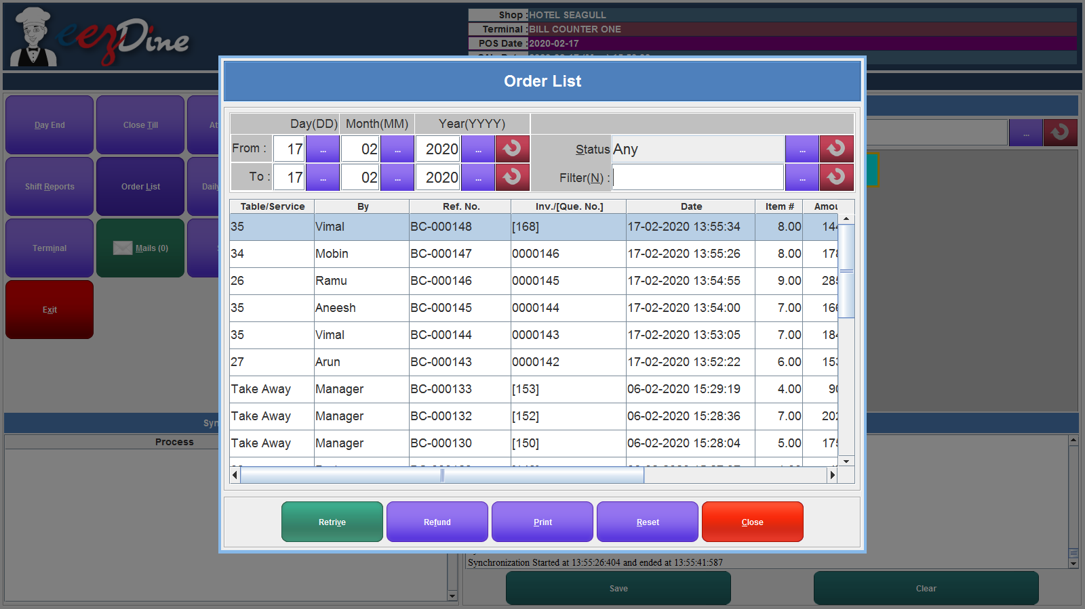

Fig: Order List Window

Here, we can see all the order details in the shop as per the given date. Enter the from date and to date to retrieve the order list. The field state defines the state of the order. When we click the button on the state field, popup the list of states as shown below.

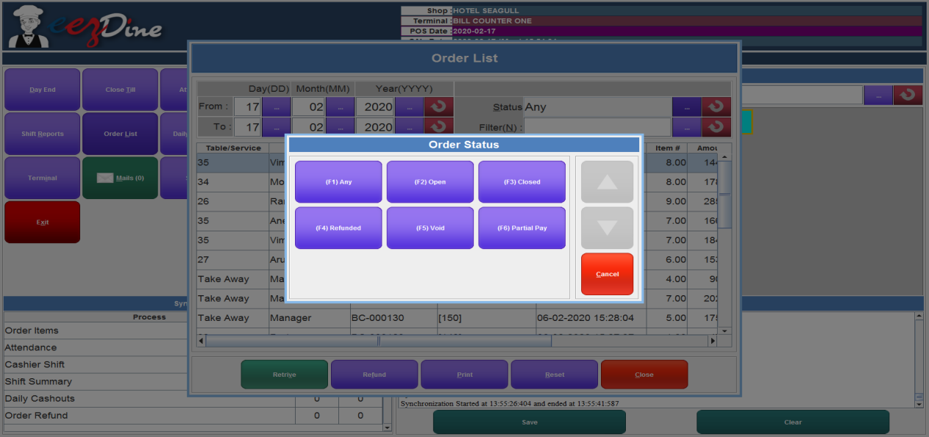

Fig: Order status list

Select the status from the list. If we want to get the order easily enter the invoice number to the filter field and click the retrieve button. If we want to refund any order, select the order from the list and click the refund button, then popup a order refund window as shown below.

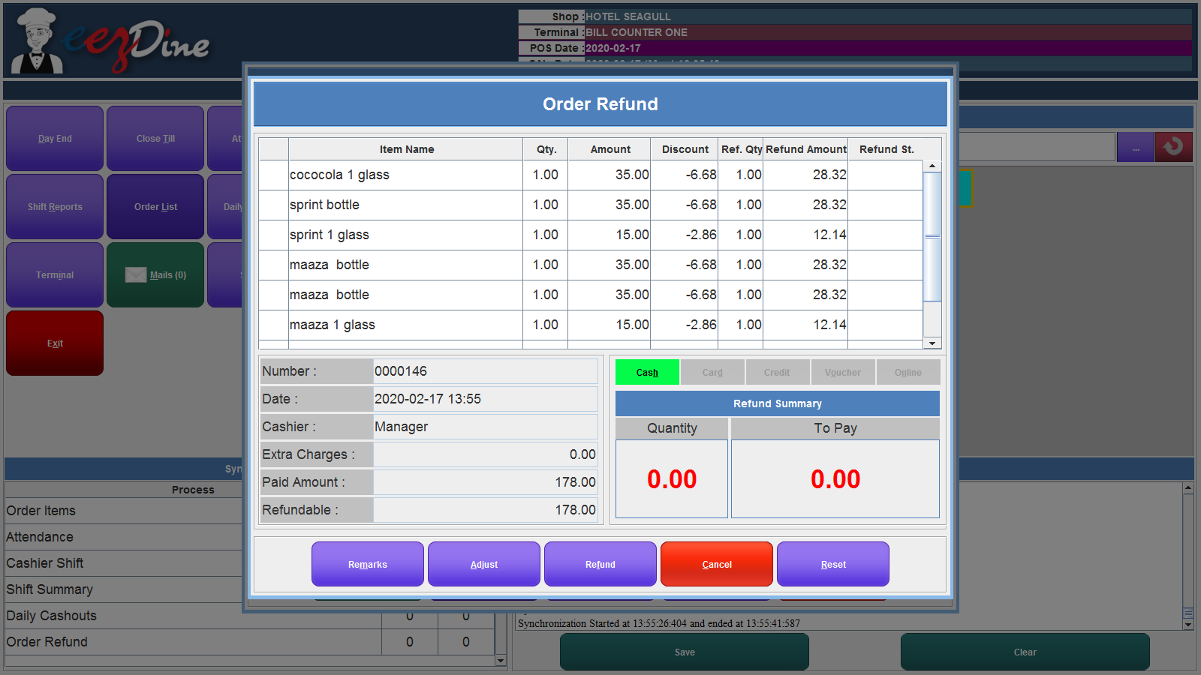

Fig: Order Refund

We can select the items we want to refund and we can also adjust the quantity or amount of the item from the list. If we want to make any correction click the reset button for resetting the details back to the initial stage. Then select the items and click the refund button. The print button used to take print, we have three options in print option: Bill receipt, Kitchen ticket and barcode labels. Select the print type, then popup a message box click the Yes button to take the print. The Reset button used to reset the changes and close button used to exit from the window.

## **2.10 Daily Expenses**

## Daily Expenses button is used to save the details of the daily expenses in the shop. When we click the daily expenses button, popup a window for authentication purposes. Enter the valid Card Number and Password for user authentication. Then open the daily expenses window as shown below.

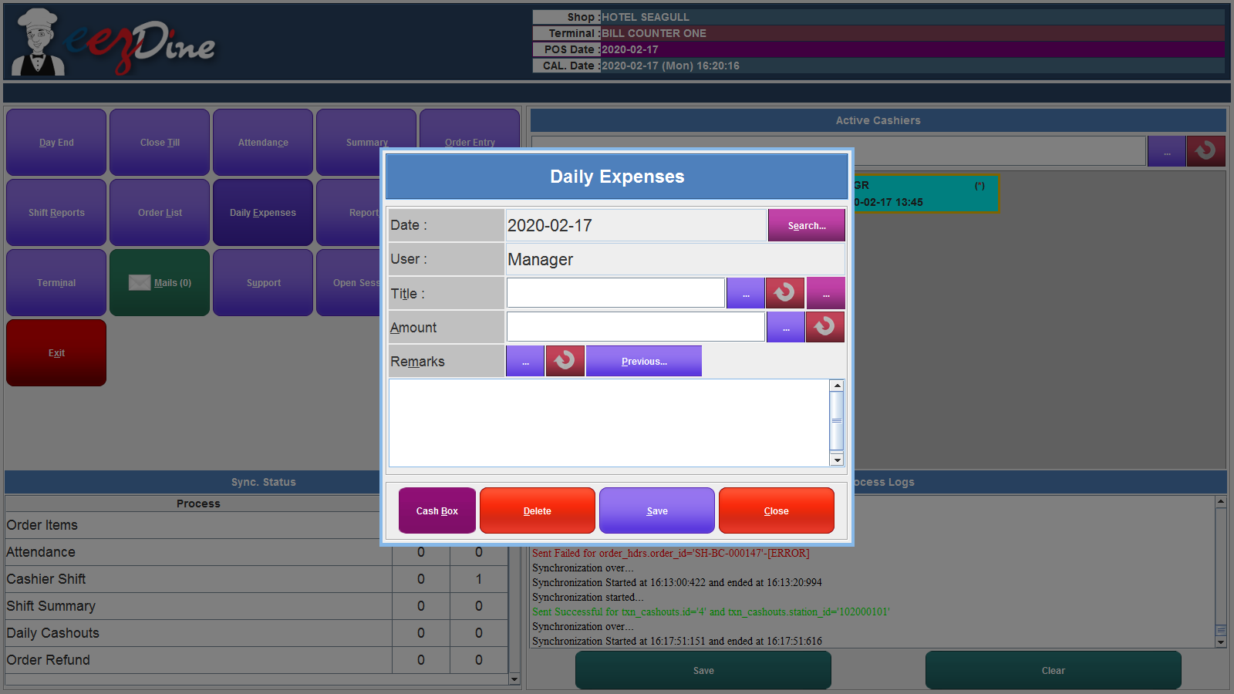

Fig: Daily Expenses

Enter the title of the daily expenses otherwise select the title from the list shown when click the button shown on the field. Then enter the Amount of expenses and enter the remarks then click the save button. If we connect the cash box to the system, click the cash box button to open the cash box automatically and enter the cash amount and title field. If we want to delete any daily expense data from the list. Click the search button then popup the list of datas entered early and select the one we want and click the delete button to delete the entry. Close button used to exit from the window.

## **2.11 Reports**

Report Button used to take the reports. When we click the report button, popup a list of reports such as Daily Advance, Daily Balance, Item Wise Sales Order, Item Wise Detailed Sales Order, Void Item List and Refund Item List. When we click the Reports button, show a list of reports. And we can select the report we want.

###### **2.11.1 Daily Advance Report**

The Daily Advance report is used to take the report of advance payment details done in the Home Delivery service or Sales Order Service. We can select the Date which we want and select the service Home Delivery or Sales Order. Then click the Print Button to take the print in A4 size. Make sure that the printer is connected to the system after giving the print option.

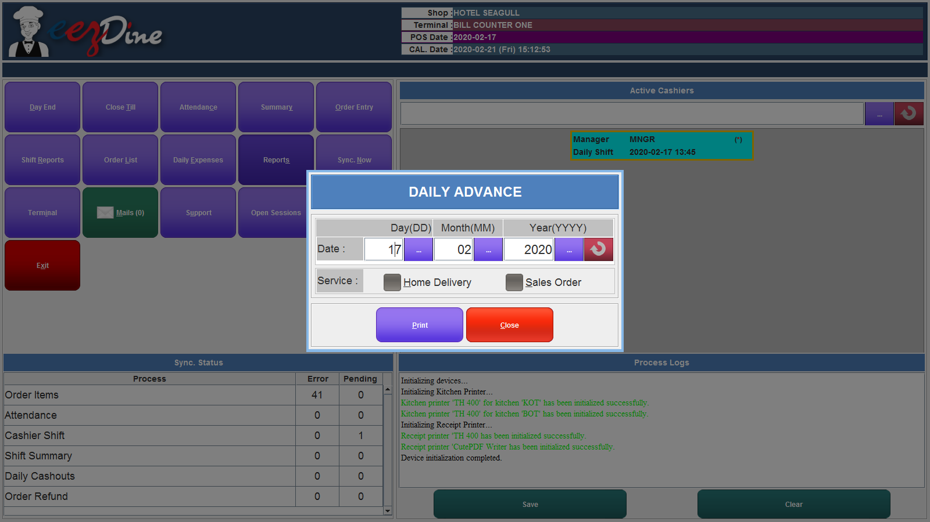

Fig: Daily Advance Report.

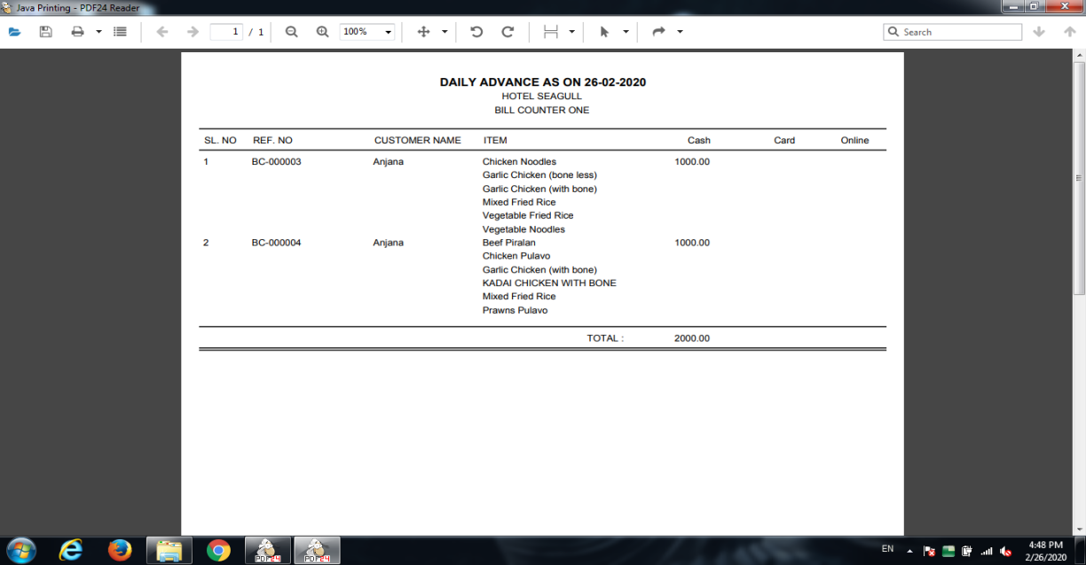

Fig : Daily Advance Report

###### **2.11.2 Daily Balance Report**

Then the Daily balance Report is used to take the Balance payment details in the Home Delivery or Sales Order Services. When we click the Daily balance report, show the window as shown below.

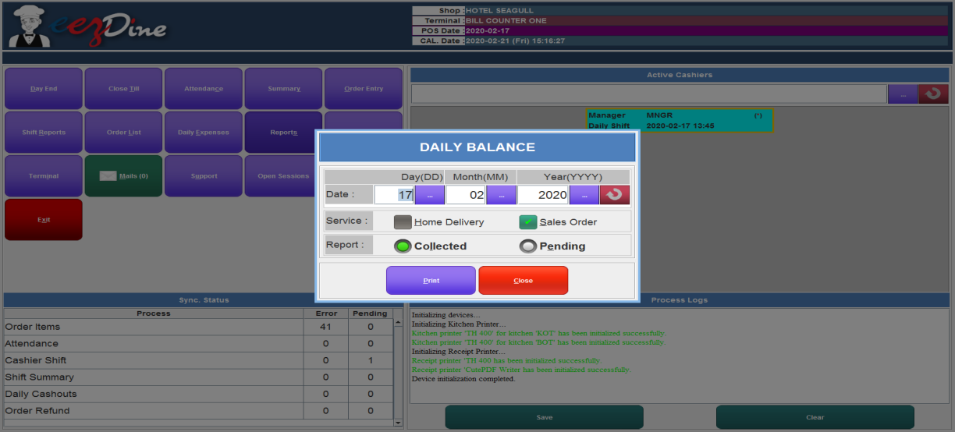

Fig: Daily balance Report

Select the Date we want and select the Services. If we want to take report on one particular service, select the home delivery or Sales order otherwise select both of them. Report field has two options: Collected and Pending. The Collected means details about the collected balance payment and the pending means the details about the order payment was pending. Then click the print button. Then the print in pdf format, make sure that the pdf printer is connected to the device. The report gives the customer name, ordered items list, total amount details, advance amount details and balance amount details. If any items are refunded, refund amount details are also shown in the report. The given print is shown below.

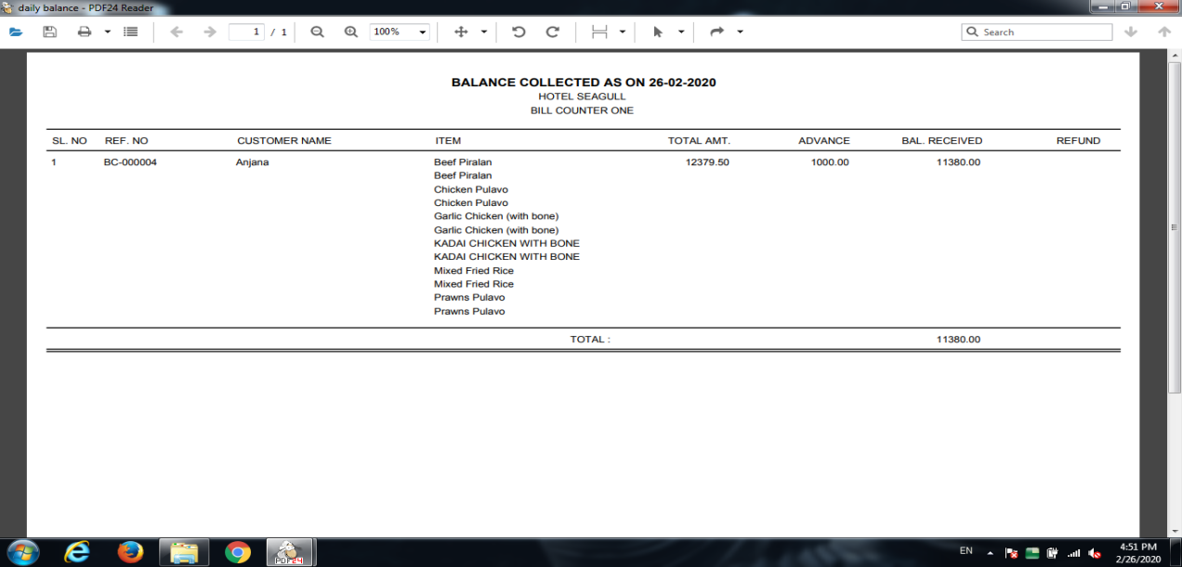

Fig: Daily Balance Report

###### **2.11.3 Item Wise Sales Order Report**

Item Wise Sales Order is used for the item wise details of the orders placed in sales order service and Home delivery service. When we select the item wise sales order report, popup a window as shown below.

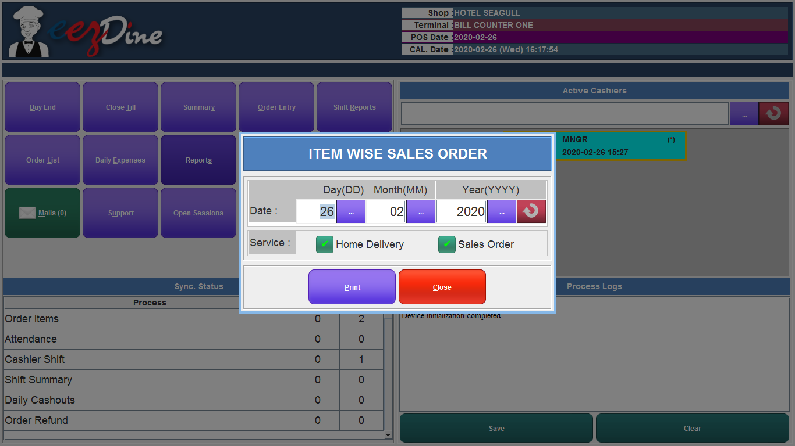

Fig: item wise sales order report

Enter the Date we want and select the services we want then click the print button to take the print of the report. Make sure that the pdf printer is connected to the system.

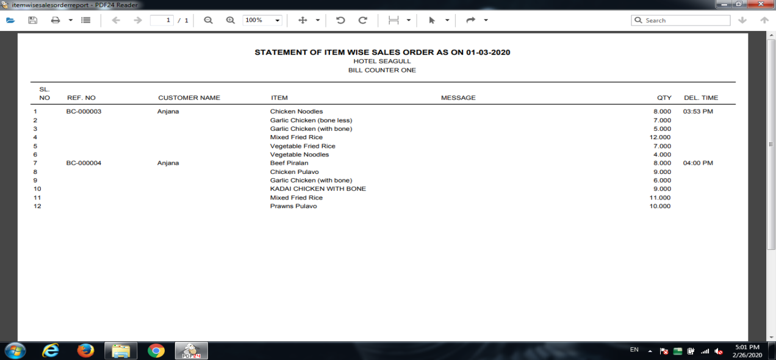

Fig: Item Wise Sales Order Report

###### 

###### **2.11.4 Item Wise Detailed Sales Order Report**

Item wise detailed sales order report is mainly used for the sales order service and home delivery services. Item wise detailed sales order report is the same as the item wise sales order report but more fields are included in this report more details like customer contact number, delivery type, delivery time etc.

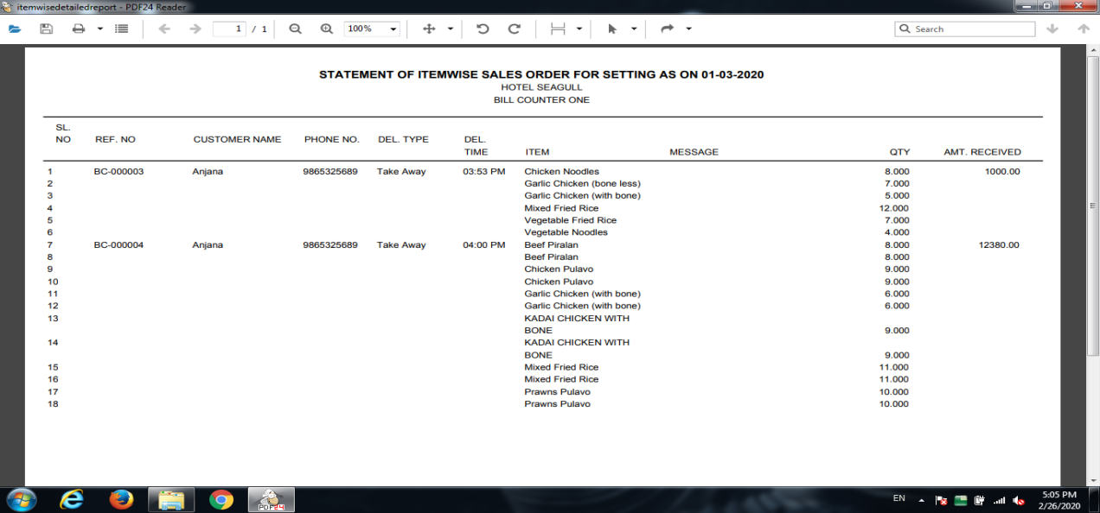

Fig: Item Wise detailed sales order report

###### **2.11.5 Void Item List Report**

A Void item list report is used to take the report of void bills in the shop of a particular date. When we select the void item list report, popup a window as shown below

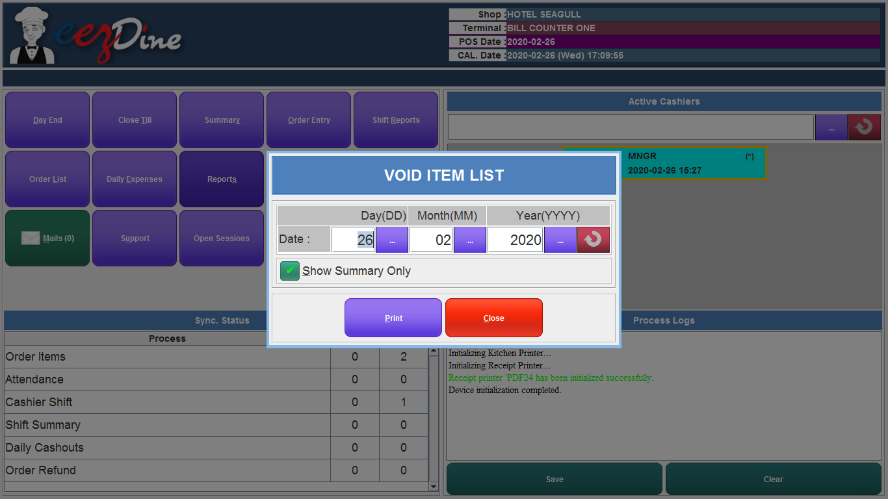

###### 

Fig: Void item list report

Enter the date we want. If we want to take the summary only put a tick mark in the show summary only check box and then click the print button. Make sure that the printer is connected.

###### **2.11.6 Refund Item List Report**

###### 

Fig: Refund Item List Report

Refund Item List Report is used to take the report of refunded items list. When we select the refund item list report, popup a window shown above and enter the Date we want and if you want only summary put a tick mark to the check box show summary only and then click the print button.

## **2.12 Sync Now Module**

Sync Now Module is used to synchronise data updated by the admin in the server. When we click the sync now button, popup a window for authentication. Enter the valid card number and password for user authentication. Then the data synchronisation window will be shown as below.

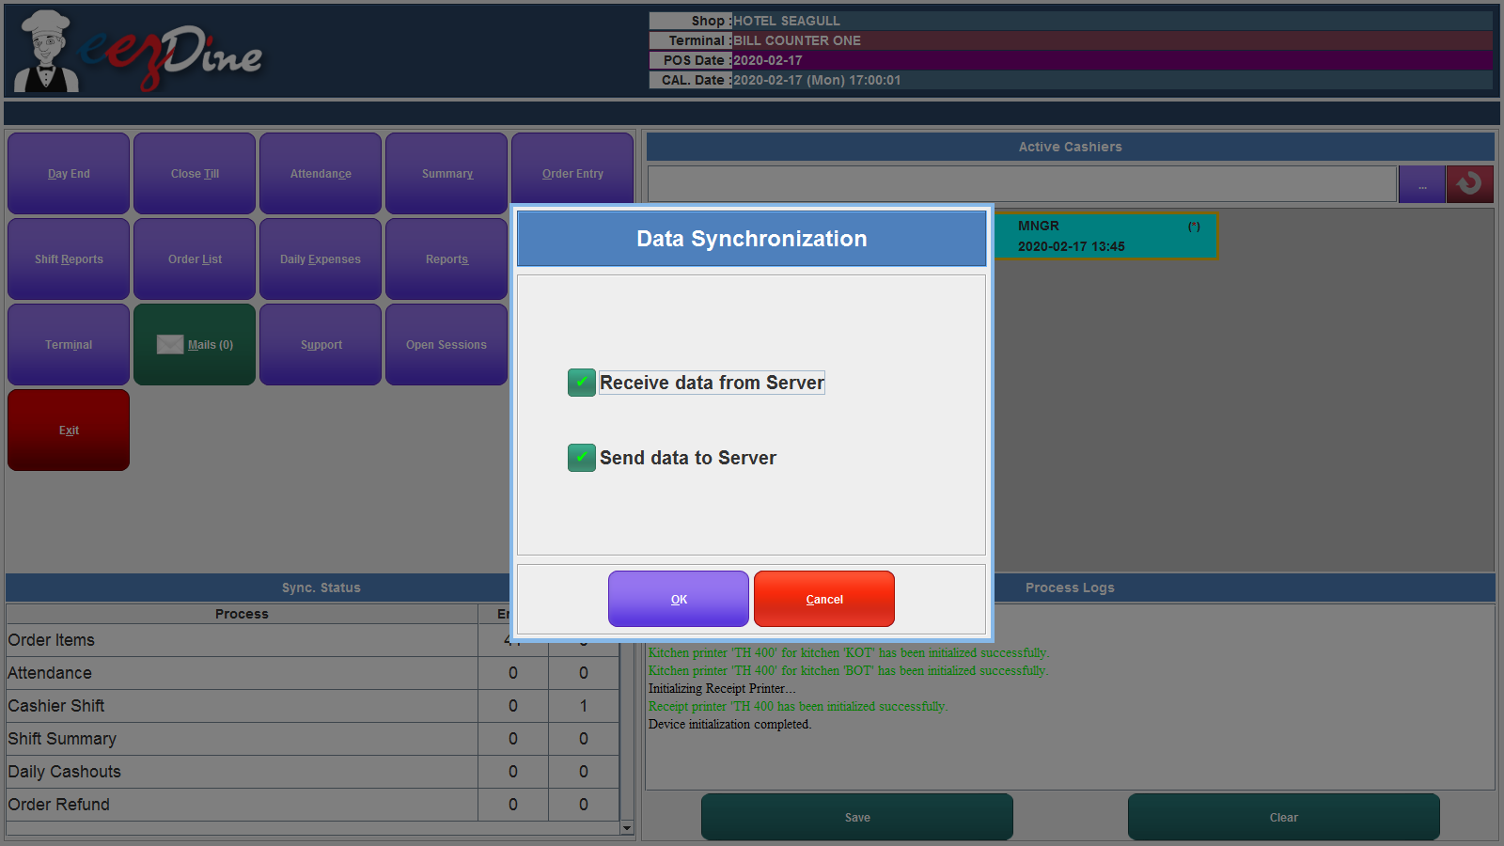

Fig: data Synchronisation window

If the admin changes any update in the server then a flash message is seen in the message panel for data synchronisation. After seeing this flash message click the sync now button for synchronisation for updating the changes in the terminal side. Click the Ok button to sync the data. After completing the synchronisation the system will restart.

## **2.13 Mails Module**

Mail module is used to see the messages from the admin. If admin wants to pass any urgent messages in the staff working in the shop, admin can send messages to the staff through this POS system. If there is any message sent by the admin the message panel shows an notification to sync the system and then the message will be seen as below.

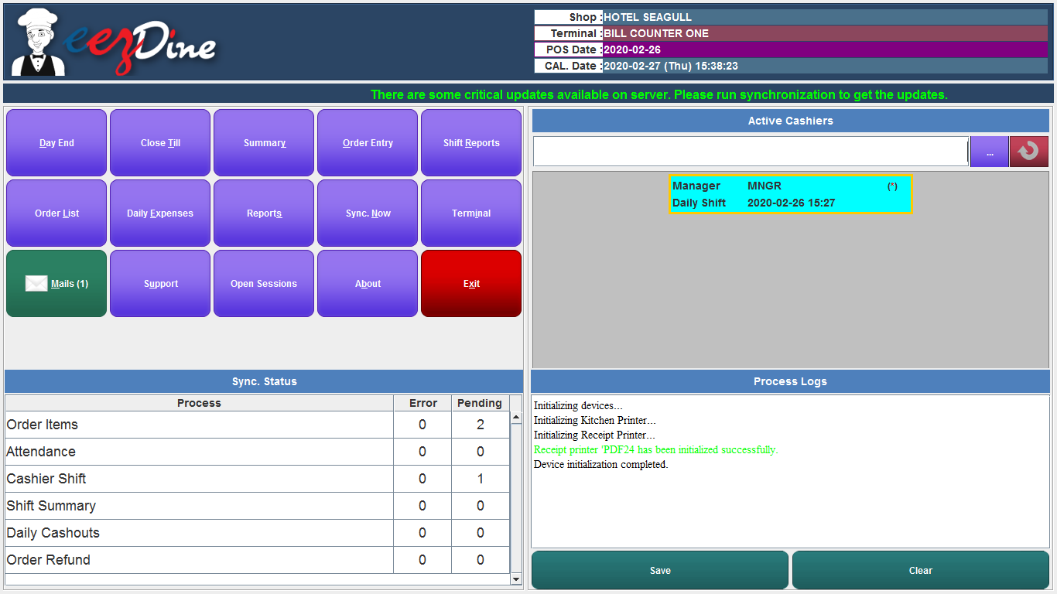

Fig: Message notification

Then click the Mails button from the window, then popup the window with a list of messages sent by the admin as shown below.

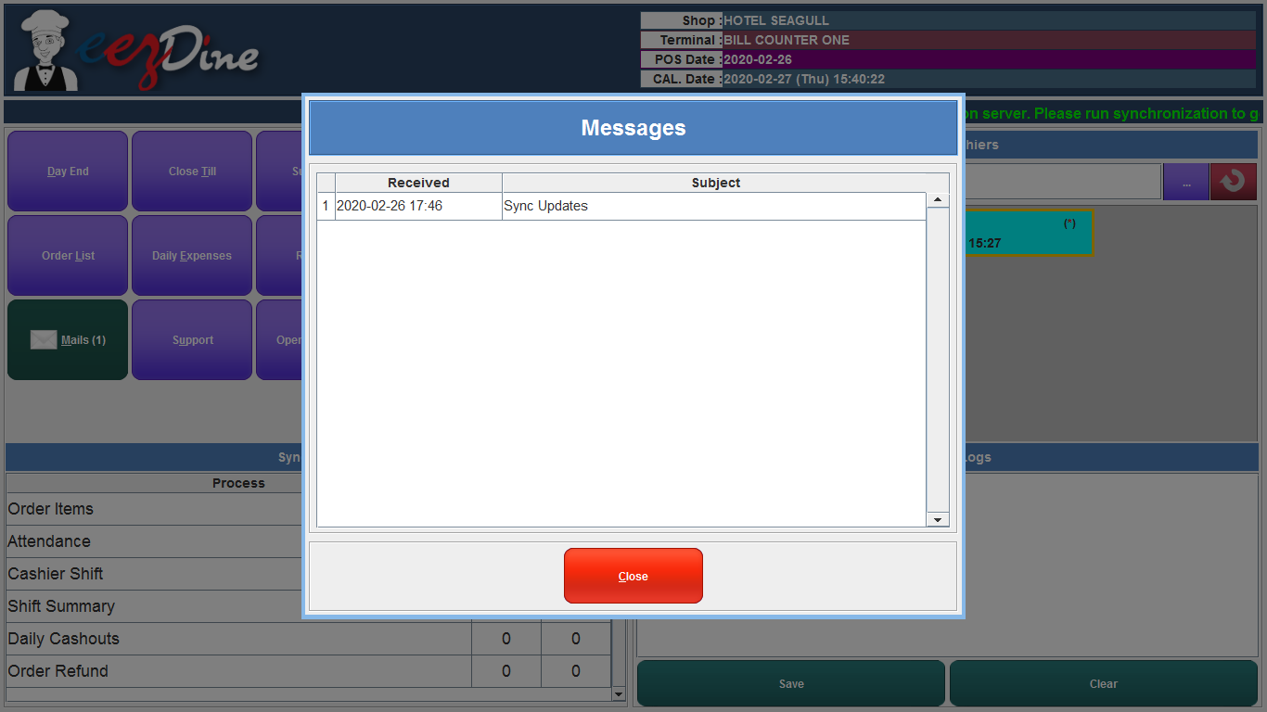

Fig: Message list

The new messages are seen in the bold letters and double click the message to see the content of the message. Then the message is seen as shown below.

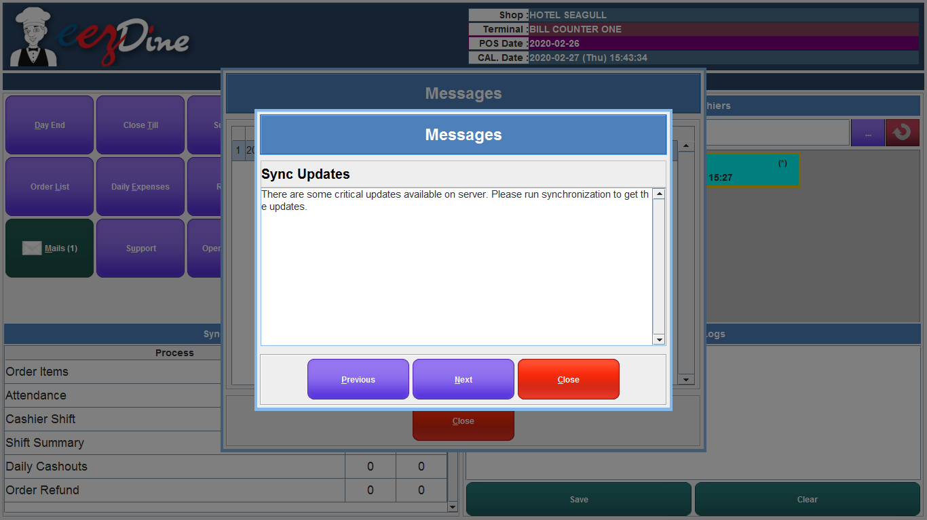

Fig: message content

The next button used to see the next message and the previous button used to see the previous messages. This module is the same as the mail button in order entry module.

## **2.14 Support Module**

## The support module is used for contacting the support team for any help. Support module used to mail any issues occured while running the system to the support team. If there are any problems occured in the system, we have limits to discuss in telephone or messages. The supporters always ask us for the database files and log files to fix the issues. The support module supports us to share the log files and database files to the support teams. Click the support button from the main window, then open the window as shown below. The window shows the text field to enter the details of the problem and two check boxes to attach log files and database files. If you want to attach the files, put a tick mark to the check boxes shown in the below window. Then click the send button to send the mail to the supporting teams.

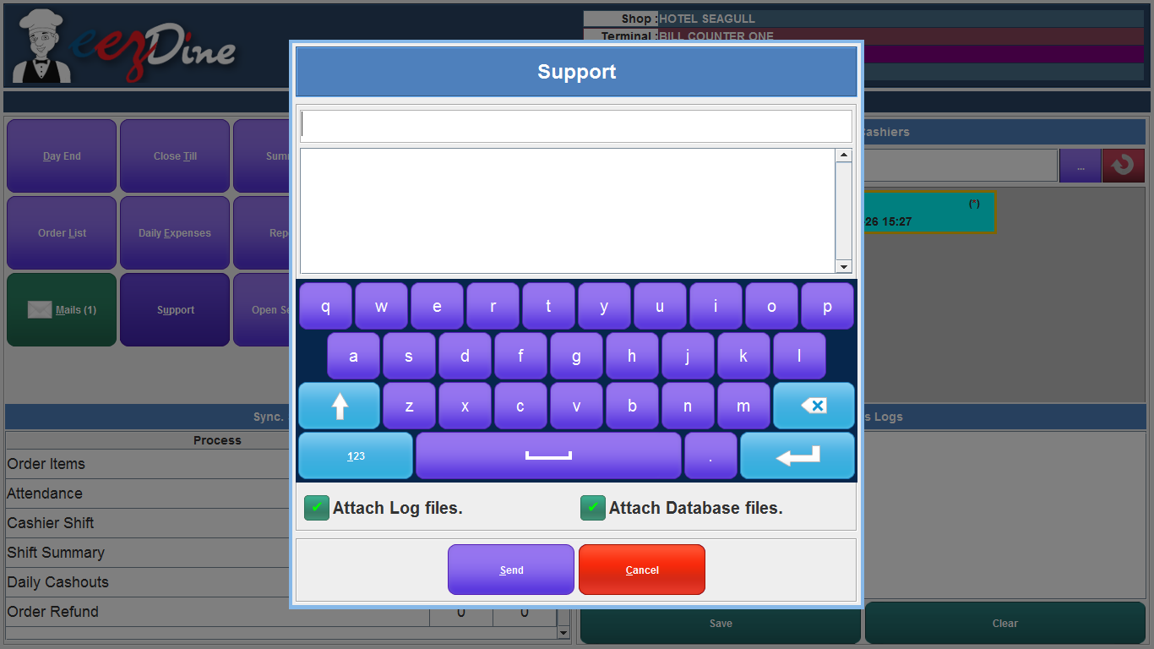

Fig: support module

## **2.15 Open Sessions Module**

## In some shops they have more than one POS system. In this situation, we want to use one of the terminal POS systems as a master and the others are slaves. All the controls are done through this master system. When we close the master system, the slave systems are not working. The open session module is used to know the list of slave systems currently working. Click the open session button from the main window, open the list of terminal currently working. The list is shown below.

Fig: open session list

## **2.16 About**

About module used for the users to know about the application details like name of the application, version, built on date, license details etc and also have details about the warning to the users. When we click the about button from the main window, popup a window as shown below.

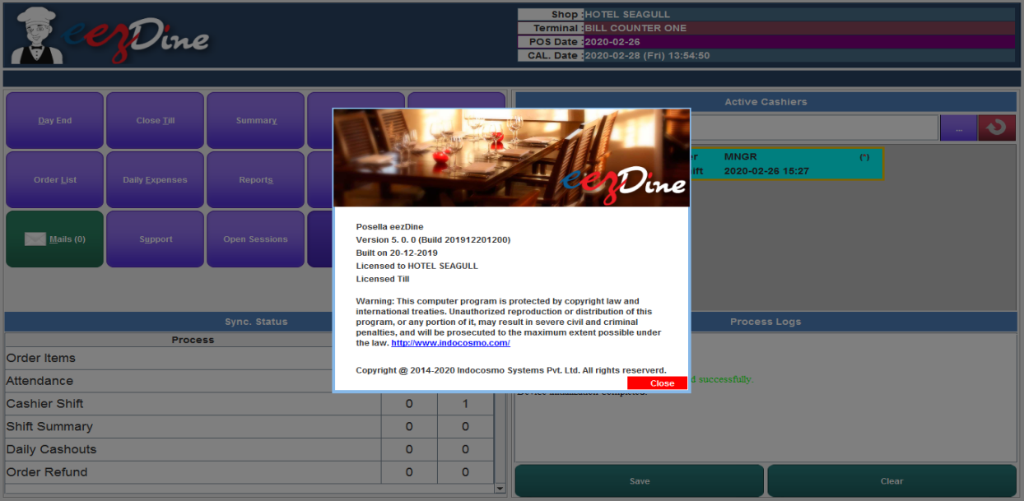

Fig: About module

## **2.17 Exit**

Exit module is used for termination from the application.

# 

## **2.18 Shortcut Keys**

###### **2.18.1 Order Entry Module**

|  |  |  |
| --- | --- | --- |
| **SL. NO.** | **Shortcut Key** | **Description** |
| 1 | Ctrl + alt + s | Service button |
|  | F1 | Select Take Away service from the list |
|  | F2 | Select Home Delivery service from the list |
|  | F3 | Select Table Service from the list |
| 2 | Alt + n | New Order |
| 3 | Alt + p | Park Order |
| 4 | Alt + o | Open order list |
| 5 | Alt + i / Ctrl + i | Order informations |
| 6 | Alt + c | Customers list |
| 7 | Alt + u | Menu |
| 8 | Alt + m / Ctrl + m | More |
| 9 | Alt + l / Ctrl + l | Lock screen |
| 10 | Alt + x / Ctrl + x | Exit from order entry module |
| 11 | F8 | Quick payment mode |
| 12 | F1 | Quick cash payment |
| 13 | F2 | Quick card payment |
| 14 | F3 | Quick credit payment |
| 15 | F9 | Standard Cash payment |
| 16 | F3 | Search items |
| 17 | F4 | Enter quantity of the item |
| 18 | F10 | Standard Card payment |
| 19 | F12 | Voucher Payment |
| 20 | Payment module |  |
|  | Alt + h | Cash payment |
|  | Alt + d | Card payment |
|  | Alt + v | Voucher payment |
|  | Alt + u | Add discount |
|  | Alt + y | Make payment |
|  | Alt + m | Add remarks |
|  | Alt + r | Reset fields |
|  | Alt + c | Close window |
|  | Alt + x | To add exact amount |
| 21 | Ctrl + s | Park order |
| 22 | Ctrl + c | Wholesale service |
| 23 | Ctrl + a | Item list view |
| 24 | Ctrl + p | Print receipt |
| 25 | Ctrl + k | Kitchen print |
| 26 | Ctrl + n | New order |
| 27 | + | Add item quantity |
| 28 | - | Reduce item quantity |
| 29 | Up arrow | Item select from the item list in order item panel |
| 30 | Down arrow | Item select from the item list in order item panel |
| 31 | Alt + 1 | Change screen keyboard to numeric / alphabets |
| 32 | Alt + 2 | Change screen keyboard to symbols |
| 33 | Item code + enter key | Item selection |
| 34 | Delete button | Item delete/ item void after parking |

###### **2.18.2 Main Screen**

|  |  |  |
| --- | --- | --- |
| **SL.NO.** | **Shortcut key** | **Description** |
| 1 | Alt + d | Day End |
| 2 | Alt + t | Close till |
| 3 | Alt + y | Summary |
| 4 | Alt + o | Order entry |
| 5 | Alt + r | Shift report |
| 6 | Alt + l | Order list |
| 7 | Alt + e | Daily expenses |
| 8 | Alt + s | Reports |
| 9 | Alt + n | Sync. Now |
| 10 | Alt + i | Terminal |
| 11 | Alt + m | Mails |
| 12 | Alt + u | Supports |
| 13 | Alt + b | About |
| 14 | Alt + x | Exit |

###### 

# 

.